UNITED STATES
SECURITIES AND EXCHANGE COMMISSION
Washington, D.C. 20549

SCHEDULE 14A

Proxy Statement Pursuant to Section 14(a) of
the Securities Exchange Act of 1934

Filed by the Registrant ☒

Filed by a party other than the Registrant ☐

Check the appropriate box:

☐ | Preliminary Proxy Statement

☐ | Confidential, for Use of the Commission Only (as permitted by Rule 14a-6(e)(2))

☐ | Definitive Proxy Statement

☒ | Definitive Additional Materials

☐ | Soliciting Material under §240.14a-12

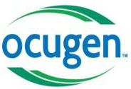
Ocugen, Inc.
(Name of Registrant as Specified in Its Charter)

(Name of Person(s) Filing Proxy Statement, if other than the Registrant)

Payment of Filing Fee (Check all boxes that apply):

☒ | No fee required

☐ | Fee paid previously with preliminary materials

☐ | Fee computed on table in exhibit required by Item 25(b) per Exchange Act Rules 14a-6(i)(1) and 0-11

Explanatory Note

On August 13, 2026, Ocugen, Inc. (the “Company”) posted the following on Stocktwits platform in connection with the Company’s special meeting of stockholders:

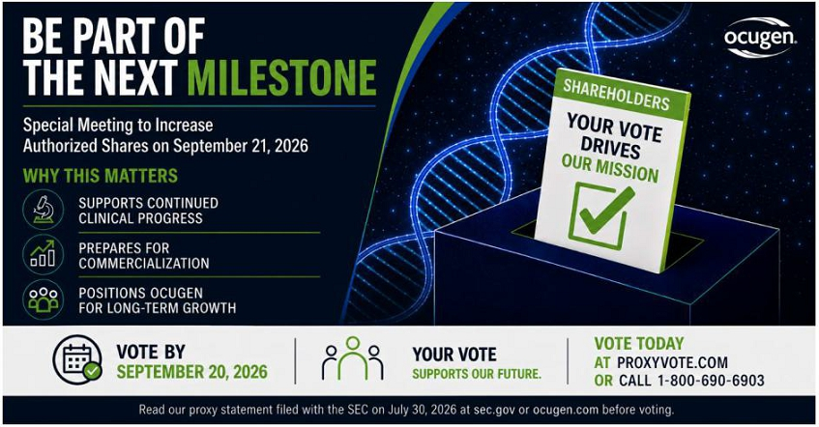
Important Stockholder Information

The Company will hold a special meeting of stockholders (the “Special Meeting”) on September 21, 2026. On July 30, 2026, the Company filed with the U.S. Securities and Exchange Commission (the “SEC”) the definitive proxy statement in connection with the Special Meeting and the solicitation of proxies (the “Proxy Statement”). The Proxy Statement contains important information about the Company, the Special Meeting and related matters.

STOCKHOLDERS ARE URGED TO READ THE PROXY STATEMENT, AND ANY OTHER RELEVANT SOLICITATION MATERIALS WHEN THEY BECOME AVAILABLE, CAREFULLY AND IN THEIR ENTIRETY BECAUSE THESE DOCUMENTS CONTAIN IMPORTANT INFORMATION CONCERNING THE PROPOSALS TO BE VOTED ON AT THE SPECIAL MEETING.

The Proxy Statement and other relevant solicitation materials (when they become available), and any and all other documents filed by the Company with the SEC, may be obtained by stockholders free of charge at the SEC’s web site at www.sec.gov. In addition, the Company’s filings with the SEC, including the Proxy Statement and other relevant solicitation materials (when they become available), may be obtained, without charge, from the Company by directing a request to the Company at its main office at 11 Great Valley Parkway, Malvern, PA 19355. Such materials are also available at ir.ocugen.com.

Participants in the Solicitation

The Company and its directors and executive officers may be deemed to be participants in the solicitation of proxies from stockholders in connection with the Special Meeting. Information regarding the Company’s directors and executive officers, including a description of their direct or indirect interests, by security holdings or otherwise, is set forth in the Proxy Statement. Information relating to the foregoing can also be found in the Company’s definitive proxy statement for its 2026 Annual Meeting of Stockholders filed with the SEC on April 28, 2026. To the extent that holdings of the Company’s securities by its directors and executive officers change compared to the amounts set forth in the Proxy Statement, such changes are required to be reflected on Statements of Changes of Beneficial Ownership of Securities on Form 4 filed with the SEC.

Cautionary Statement

This filing contains forward-looking statements with respect to Ocugen’s operations, business and prospects. Forward-looking statements can be identified by the use of such words as “may,” “should,” “will,” “could,” “estimates,” “predicts,” “potential, “continue,” “anticipates,” “believes,” “plans,” “expects,” “future,” “intends,” “projects,” the negative of these terms and other comparable terminology. These forward-looking statements may include projections of, or guidance on, the anticipated benefits of the matters to be acted upon at the Special Meeting, Ocugen’s future growth strategies, commercial readiness, clinical progress, descriptions of business initiatives and anticipated trends in Ocugen’s business or financial results.

Forward-looking statements are neither historical facts, nor assurance of future performance. Instead, these statements are based on current beliefs, expectations and assumptions regarding Ocugen’s business, strategies, projections, as well as anticipated events and trends. Forward-looking statements are subject to inherent uncertainties, risks and changes in circumstances that are difficult to predict and many of which are outside of Ocugen’s control, and Ocugen’s actual results and financial condition may differ materially from those indicated in the forward-looking statements. Therefore, you should not unduly rely on any of these forward-looking statements. Any forward-looking statement is based only on information currently available and speaks only as of the date when made. Ocugen undertakes no obligation, other than as required by law, to update or revise any forward-looking statements, whether as a result of new information, future events or otherwise.

A discussion of certain risks and uncertainties affecting Ocugen, and some of the factors that could cause Ocugen’s actual results to differ materially from those described in the forward-looking statements, can be found in the sections entitled “Risk Factors” and “Management’s Discussion and Analysis of Financial Condition and Results of Operations” in Ocugen’s Annual Report on Form 10-K for the year ended December 31, 2025 and Ocugen’s Quarterly Reports on Form 10-Q for the quarters ended March 31, 2026 and June 30, 2026, as applicable.

