UNITED STATES

SECURITIES AND EXCHANGE COMMISSION

WASHINGTON, D.C. 20549

FORM 8-K

CURRENT REPORT

Pursuant to Section 13 or 15(d)

of the Securities Exchange Act of 1934

Date of Report (Date of earliest event reported): May 5, 2026

OCUGEN, INC.

(Exact name of registrant as specified in its charter)

Delaware

(State or other jurisdiction

of incorporation)

001-36751

(Commission File

Number)

04-3522315

(IRS Employer

Identification No.)

11 Great Valley Parkway

Malvern, Pennsylvania

(Address of principal executive offices)

19355

(Zip Code)

Registrant’s telephone number, including area code: (484) 328-4701

N/A

(Former name or former address, if changed since last report.)

Check the appropriate box below if the Form 8-K filing is intended to simultaneously satisfy the filing obligation of the registrant under any of the following provisions (see General Instruction A.2. below):

- Written communications pursuant to Rule 425 under the Securities Act (17 CFR 230.425)

- Soliciting material pursuant to Rule 14a-12 under the Exchange Act (17 CFR 240.14a-12)

- Pre-commencement communications pursuant to Rule 14d-2(b) under the Exchange Act (17 CFR 240.14d-2(b))

- Pre-commencement communications pursuant to Rule 13e-4(c) under the Exchange Act (17 CFR 240.13e-4(c)) Securities registered pursuant to Section 12(b) of the Act:
 |  | Trading |  | Name of each exchange
Title of each class |  | Symbol(s) |  | on which registered
Common Stock, par value $0.01 per share |  | OCGN |  | The Nasdaq Stock Market LLC
 |  |  |  | (The Nasdaq Capital Market)

Indicate by check mark whether the registrant is an emerging growth company as defined in Rule 405 of the Securities Act of 1933 (§ 230.405 of this chapter) or Rule 12b-2 of the Securities Exchange Act of 1934 (§ 240.12b-2 of this chapter).

Emerging growth company ☐

If an emerging growth company, indicate by check mark if the registrant has elected not to use the extended transition period for complying with any new or revised financial accounting standards provided pursuant to Section 13(a) of the Exchange Act. ☐

Item 2.02 Results of Operations and Financial Condition.

On May 5, 2026, Ocugen, Inc (the “Company”) issued a press release announcing certain financial results for the quarter ended March 31, 2026. The Company has scheduled a conference call and webcast for 8:30 a.m. Eastern Time on May 5, 2026, to discuss these financial results and business updates. The Company will use presentation materials in connection with the conference call and webcast, which presentation materials will be posted on the Company's website at www.ocugen.com. Copies of the press release and presentation materials are furnished herewith as Exhibit 99.1 and Exhibit 99.2, respectively, to this Current Report on Form 8-K (this “Report”) and incorporated herein by reference.

The information disclosed under Item 2.02 of this Report, including Exhibit 99.1 and Exhibit 99.2, is being furnished and shall not be deemed “filed” for purposes of Section 18 of the Securities Exchange Act of 1934, as amended (the "Exchange Act"), or otherwise subject to the liabilities of that section, and shall not be deemed to be incorporated by reference in any Company filing under the Securities Act of 1933, as amended (the “Securities Act”), or the Exchange Act, except as expressly set forth by specific reference in such filing.

Item 8.01 Other Events.

On May 5, 2026, the Company announced the pricing of its previously announced private offering (the “Offering”) of $115.0 million aggregate principal amount of 6.75% Convertible Senior Notes due 2034 (the “Notes”). The Company has also granted to Oppenheimer & Co. Inc. (the “Initial Purchaser”) an option to purchase, for settlement within a 13-day period from the date of initial issuance of the Notes, up to an additional $15.0 million aggregate principal amount of the Notes. The Offering is expected to close on or about May 7, 2026, subject to the satisfaction of customary closing conditions.

The Notes have not been, and will not be, registered under the Securities Act of 1933, as amended (the “Securities Act”), or any applicable state or foreign securities laws, and were offered only to qualified institutional buyers in reliance on Rule 144A promulgated under the Securities Act.

The Company estimates that the net proceeds from this offering will be approximately $99.5 million (or approximately $112.6 million if the Initial Purchaser exercises its option to purchase additional Notes in full), after deducting the Initial Purchaser’s discount and estimated offering expenses payable by the Company. The Company intends to use approximately $32.7 million of the net proceeds from the Offering to fully repay the outstanding principal amount, plus accrued and unpaid interest on, the loan and pay other obligations, including the related prepayment fee, in connection therewith, outstanding under the Loan and Security Agreement that the Company is party to with Avenue Venture Opportunities Fund II, L.P. and Avenue Venture Opportunities Fund, L.P. as lenders and Avenue Capital Management II, L.P. as administrative agent and collateral agent (the “Avenue Loan Agreement”), and terminate the Avenue Loan Agreement and all related loan documents. The Company intends to use the remaining net proceeds from the offering for general corporate purposes.

On May 5, 2026, the Company issued a press release announcing the pricing of the Notes. A copy of the press release is attached hereto as Exhibit 99.3 and is incorporated herein by reference.

Neither this Report nor the press release attached hereto as Exhibit 99.3 constitutes an offer to sell or a solicitation of an offer to buy the Notes, any shares of the Company’s common stock issuable upon conversion of the Notes, or any other securities, nor shall it constitute an offer, solicitation or sale in any jurisdiction, in which such an offer, solicitation or sale would be unlawful. Any offer of the Notes can be made only by means of a private offering memorandum.

1

Item 9.01 Financial Statements and Exhibits.

(d) Exhibits.

Exhibit Number |  | Description
99.1 |  | Earnings Press Release of Ocugen, Inc., dated May 5, 2026.
99.2 |  | Earnings Release Presentation of Ocugen, Inc., issued May 5, 2026.
99.3 |  | Pricing Press Release of Ocugen, Inc., dated May 5, 2026.
104 |  | Cover Page Interactive Data File (embedded within the Inline XBRL document).

Cautionary Note on Forward-Looking Statements

This Report contains forward-looking statements within the meaning of The Private Securities Litigation Reform Act of 1995, which are subject to risks and uncertainties, including but not limited to, statements regarding the anticipated terms of the Notes; the size of the Offering, including the Initial Purchaser’s option to purchase additional Notes; the anticipated use of proceeds from the Offering, including the repayment of obligations under the Avenue Loan Agreement; the completion of the Offering, and other statements contained in this Report that are not historical facts. The Company may, in some cases, use terms such as “predicts,” “believes,” “potential,” “proposed,” “continue,” “estimates,” “anticipates,” “expects,” “plans,” “intends,” “may,” “could,” “might,” “will,” “should,” or other words that convey uncertainty of future events or outcomes to identify these forward-looking statements. Such statements are subject to numerous important factors, risks, and uncertainties that may cause actual events or results to differ materially from the Company’s current expectations, including, but not limited to: uncertainties related to market conditions and whether the Offering will be completed on the anticipated terms or at all; the impact of the Offering on the market price of the Company’s common stock; risks related to the potential dilution to holders of the Company’s common stock; and uncertainties regarding the conversion price and other terms of the Notes. These and other risks and uncertainties are more fully described in the Company’s periodic filings with the SEC, including the risk factors described in the section entitled “Risk Factors” in the quarterly and annual reports that the Company files with the SEC. Any forward-looking statements that the Company makes in this Report speak only as of the date of this report. Except as required by law, the Company assumes no obligation to update forward-looking statements contained in this Report whether as a result of new information, future events, or otherwise, after the date of this Report.

2

SIGNATURE

Pursuant to the requirements of the Securities Exchange Act of 1934, the registrant has duly caused this report to be signed on its behalf by the undersigned hereunto duly authorized.

 |  | OCUGEN, INC.
Date: May 5, 2026 | By: /s/ Shankar Musunuri
 |  | Name: Shankar Musunuri
 |  | Title: Chairman, Chief Executive Officer, & Co-Founder
 | 3

Exhibit 99.1

Ocugen Provides Business Update with First Quarter 2026 Financial Results

Conference Call and Webcast Today at 8:30 a.m. ET

- Positive 12-month data from the OCU410 Phase 2 ArMaDa clinical trial for geographic atrophy (GA) indicates a statistically significant (p<0.05) 31% reduction in lesion size and 27% EZ preservation (correlated to visual function) in optimal dose for Phase 3

  - About 20% of patients demonstrated no progression of disease and 75% of subjects showed > 30% reduction in Iesion growth compared to control, with a favorable safety and tolerability profile

  - Allows robust registrational Phase 3 trial design, a potential combined U.S./EU trial with 300 subjects, with adaptive design powered at over 95%

- Trial enrollment complete for OCU400 for retinitis pigmentosa (RP) and OCU410ST for Stargardt disease registration trials, and on target to complete two Biologics License Application (BLA) submissions by 2027

- The closing of a private offering of $115 million aggregate principal amount ($130 million if overallotment is exercised) of 6.75% convertible senior notes due 2034, with a conversion premium of 45%, is expected to extend cash runway into 2028, subject to customary closing conditions

- The Company expects to utilize $32.7 million of net proceeds from the Notes to retire the Avenue debt (12.5% interest rate)

MALVERN, Pa., May 5, 2026 (GLOBE NEWSWIRE) – Ocugen, Inc. (“Ocugen” or the “Company”) (NASDAQ: OCGN), a pioneering biotechnology leader in gene therapies for blindness diseases, today reported first quarter 2026 financial results along with a general business update.

With the recent offering, the Company is expected to have cash, cash equivalents, and restricted cash of $112.1 million, at closing, which includes the Avenue debt payoff. The Company will use the remaining net proceeds for general corporate purposes and expects to extend cash runway into 2028. The offering is expected to close on May 7, 2026, subject to customary closing conditions and includes an option to retire the debt with a cash payment. If the remaining Janus Henderson warrants are exercised, the Company will receive an additional $15 million in gross proceeds increasing expected cash, cash equivalents, and restricted cash to $127.1 million.

“In the first few months of 2026, we have completed enrollment of two of our late-stage programs and are diligently working toward initiating our first BLA submission for RP and registration trial for dry AMD later this year,” said Dr. Shankar Musunuri, Chairman, Chief Executive Officer, and Co-Founder of Ocugen. “We are executing well against our plans with the highest productivity per employee rate compared to our peers, adequate cash runway with the recent offering, and key milestone achievement to create long-term value creation for our patients and shareholders.”

Enrollment for liMeliGhT, the first and largest gene therapy registrational trial for broad RP patients (N=140), was completed, reflecting strong engagement from investigators and patients. The OCU400 Phase 3 clinical trial includes representation of a wide range of genetic mutations associated with early to advanced stages of clinical and/or genetic diagnosis of RP (over 25 genetic mutations), and patient response is intended to support the gene-agnostic mechanism of action of Ocugen’s novel modifier gene therapy platform. The Company plans to initiate the rolling BLA submission for OCU400 in the third quarter of 2026 and complete the BLA submission by the second quarter of 2027.

Manufacturing readiness for OCU400 is well underway and completion of process performance qualification (PPQ) batches remains on track for the second quarter of 2026. Approximately 300,000 people in the U.S. and Europe are living with RP, and OCU400 is intended as a treatment for early to advanced cases of RP, with potential approval in the fourth quarter of 2027.

GARDian3 clinical trial enrollment and dosing were completed ahead of schedule. GARDian3 is a multicenter, randomized, masked, pivotal Phase 2/3 confirmatory registration trial designed to evaluate the efficacy and safety of OCU410ST in patients with all mutations of Stargardt disease. The study enrolled 63 subjects diagnosed with Stargardt disease. Subjects randomized to the treatment group received a one-time subretinal injection of OCU410ST in the eye with poorer visual acuity, while the untreated control group did not receive any treatment. The primary endpoint is to evaluate the reduction in atrophic lesion size at 12 months. Key secondary endpoints include improvements in best corrected visual acuity (BCVA) and low luminance visual acuity (LLVA), compared to controls. Observational endpoints include preservation of Ellipsoid Zone (EZ), which correlates to visual function. While demonstrating functional benefit via visual acuity within 12 months can be challenging due to the disease’s natural history, it is believed that preservation of EZ will serve as a meaningful and early indicator of visual function.

The interim outcome analysis of 24 subjects at 8 months post-OCU410ST (16 treated and 8 controls) is planned for the third quarter of 2026. Topline results are expected in the second quarter of 2027 with the BLA submission by mid-2027. Interim outcome analysis via adaptive design is typically introduced in pivotal trials to minimize risk. OCU410ST represents a potential first-in-class, one-time modifier gene therapy for all 100,000 patients in the U.S. and Europe with Stargardt disease.

Topline 12-month data from the OCU410 Phase 2 ArMaDa clinical trial for geographic atrophy secondary to dry age-related macular degeneration was announced in March 2026 and demonstrates a statistically significant (p< 0.05) reduction in lesion growth (31%) versus control at 12 months with the optimal dose—medium dose—intended for Phase 3. The data suggest a potential 2X treatment benefit compared to 15% and 22% reductions reported for currently approved therapies at 12 and 24 months, respectively.

In the Phase 2 study, the safety and efficacy of OCU410 in patients with GA secondary to dAMD are being assessed. Fifty-one (51) patients aged 50 years and older with GA lesions within the foveal or non-foveal region were randomized 1:1:1 to receive a single subretinal administration of OCU410 at the medium dose, high dose, or no treatment in the control group. The primary endpoint was change in GA lesion size at 12 months, measured in square millimeters by fundus autofluorescence, an FDA-accepted structural endpoint used in recent GA registration trials. Exploratory endpoints included assessment of EZ preservation. The data showed no disease progression in approximately 20% of treated subjects, and 75% of treated subjects demonstrated greater than 30% reduction in lesion growth. The Company plans to initiate the OCU410 Phase 3 registrational trial in the third quarter of 2026 with potential BLA filing by 2028. As a potential one-time treatment for life, OCU410 could eliminate the treatment burden and patient fatigue with up to 40% drop-out rates reported with current approved therapies and provide a one-time solution for the 2-3 million patients in the U.S. and Europe with GA. OCU410 has potential to become a new standard of care for patients across the globe.

Executive leadership has participated in significant investor and industry conferences, including the U.S. Department of Commerce 2026 Certified Trade Mission to Singapore; Oppenheimer’s 3rd Annual Innovation on the Island Biotech Summit; and the 2026 Cell & Gene Meeting on the Mediterranean, hosted by the Alliance for Regenerative Medicine. Through these forums, Ocugen reached a wide audience and informed them about the importance of changing the treatment paradigm for blindness diseases by potentially bringing transformative modifier gene therapies to the masses.

“We are actively pursuing a variety of business development opportunities to prepare for global commercialization,” said Dr. Musunuri. “Potential commercial partnerships will allow us to effectively provide market access to patients who are in desperate need for rescue from blindness diseases globally while growing shareholder value.”

Business Updates

Novel Modifier Gene Therapy Platform—Targeting Three BLA Filings in the Next Three Years

OCU400

- Completed Phase 3 liMeliGhT enrollment (N=140 subjects). Topline Phase 3 data expected in the first quarter of 2027, advancing OCU400 towards potential approval in the fourth quarter of 2027 as a treatment option for early- to late-stage RP.

OCU410ST

- Early completion of enrollment and dosing—less than nine months—in the Phase 2/3 pivotal confirmatory trial (N=63 subjects). Plan to submit the BLA for OCU410ST by mid-2027.

OCU410

- Announced positive 12-month topline data from the Phase 2 ArMaDa clinical trial. On track to meet with FDA/EMA to align on the Phase 3 study design and initiate Phase 3 by the third quarter of 2026.

Other Programs

OCU200

- Completed Phase 1 clinical trial enrollment in the first quarter of 2026.

OCU500

- NIAID intends to initiate the OCU500 Phase 1 clinical trial in the second quarter of 2026. First Quarter 2026 Financial Results

- The Company received $37.5 million in gross proceeds inclusive of $15 million, due to exercised warrants, in the first quarter of 2026. The Company’s cash, cash equivalents, and restricted cash totaled $32.2 million as of March 31, 2026, compared to $18.9 million as of December 31, 2025. With the recent offering, the Company is expected to have cash, cash equivalents, and restricted cash of $112.1 million, at closing, which includes the Avenue debt payoff.

- The Company had 338.3 million shares of common stock outstanding as of March 31, 2026

- Total operating expenses for the three months ended March 31, 2026 were $19.4 million and included research and development expenses of $11.3 million and general and administrative expenses of $8.1 million, compared to total operating expenses for the three months ended March 31, 2025 of $16.0 million that included research and development expenses of $9.5 million and general and administrative expenses of $6.5 million.

- Ocugen reported a $(0.06) net loss per common share for the three months ended March 31, 2026 compared to a $(0.05) net loss per common share for the three months ended March 31, 2025.

Conference Call and Webcast Details

Ocugen has scheduled a conference call and webcast for 8:30 a.m. ET today to discuss the financial results and recent business highlights. Ocugen’s senior management team will host the call, which will be open to all listeners. There will also be a question-and-answer session following the prepared remarks.

Attendees are invited to participate on the call or webcast using the following details:

Dial-in Numbers: (800) 715-9871 for U.S. callers and (646) 307-1963 for international callers

Conference ID: 4973685

Webcast: Available on the events section of the Ocugen investor site

A replay of the call and archived webcast will be available for approximately 45 days following the event on the Ocugen investor site.

About Ocugen, Inc. Ocugen, Inc. is a pioneering biotechnology leader in gene therapies for blindness diseases. Our breakthrough modifier gene therapy platform has the potential to address significant unmet medical need for large patient populations through our gene-agnostic approach. Unlike traditional gene therapies and gene editing, Ocugen’s modifier gene therapies address the entire disease—complex diseases that are potentially caused by imbalances in multiple gene networks. Currently we have programs in development for inherited retinal diseases and blindness diseases affecting millions across the globe, including retinitis pigmentosa, Stargardt disease, and geographic atrophy— late-stage dry age-related macular degeneration. Discover more at www.ocugen.com and follow us on X and LinkedIn.

Cautionary Note on Forward-Looking Statements This press release contains forward-looking statements within the meaning of The Private Securities Litigation Reform Act of 1995, including, but not limited to, strategy, business plans and objectives for Ocugen’s clinical programs, plans and timelines for the preclinical and clinical development of Ocugen’s product candidates, including the therapeutic potential, clinical benefits and safety thereof, expectations regarding timing, success and data announcements of current ongoing preclinical and clinical trials, including the timing of enrollment and data readouts, the ability to initiate new clinical programs, Ocugen’s financial condition and expected cash runway into 2028, statements regarding qualitative assessments of available data, potential benefits, expectations for ongoing clinical trials, anticipated regulatory filings and anticipated development timelines, statements regarding potential market size and commercial possibilities of Ocugen’s product candidates, which are subject to risks and uncertainties. We may, in some cases, use terms such as “predicts,” “believes,” “potential,” “proposed,” “continue,” “estimates,” “anticipates,” “expects,” “plans,” “intends,” “may,” “could,” “might,” “will,” “should,” or other words that convey uncertainty of future events or outcomes to identify these forward-looking statements. Such statements are subject to numerous important factors, risks, and uncertainties that may cause actual events or results to differ materially from our current expectations, including, but not limited to, the risks that preliminary, interim and top-line clinical trial results may not be indicative of, and may differ from, final clinical data; that unfavorable new clinical trial data may emerge in ongoing clinical trials or through further analyses of existing clinical trial data; that earlier non-clinical and clinical data and testing of may not be predictive of the results or success of later clinical trials; that that clinical trial data are subject to differing interpretations and assessments, including by regulatory authorities; uncertainties related to whether the offering of the Notes will be completed on anticipated terms or at all; the impact of the offering of the Notes on the market price of the Company’s common stock; and risks related to the potential dilution to holders of the Company’s common stock. These and other risks and uncertainties are more fully described in our annual and periodic filings with the Securities and Exchange Commission (SEC), including the risk factors described in the section entitled “Risk Factors” in the quarterly and annual reports that we file with the SEC. Any forward-looking statements that we make in this press release speak only as of the date of this press release. Except as required by law, we assume no obligation to update forward-looking statements contained in this press release whether as a result of new information, future events, or otherwise, after the date of this press release.

Contact:

Candice Masse

astr partners

candice.masse@astrpartners.com

OCUGEN, INC.

CONDENSED CONSOLIDATED BALANCE SHEETS

(in thousands, except share and per share amounts)

(Unaudited)

 | March 31, 2026 |  |  |  | December 31, 2025
Assets
Current assets
Cash | $ | 31,855 |  | $ | 18,571
Prepaid expenses and other current assets |  | 6,696 |  |  | 5,769
Total current assets |  | 38,551 |  |  | 24,340
Property and equipment, net |  | 13,830 |  |  | 14,392
Restricted cash |  | 318 |  |  | 316
Other assets |  | 4,206 |  |  | 4,468
Total assets | $ | 56,905 |  | $ | 43,516
Liabilities and stockholders' equity
Current liabilities
Accounts payable | $ | 3,241 |  | $ | 6,202
Accrued expenses and other current liabilities |  | 11,612 |  |  | 14,733
Operating lease obligations |  | 850 |  |  | 858
Current portion of long-term debt |  | 5,005 |  |  | 1,250
Total current liabilities |  | 20,708 |  |  | 23,043
Non-current liabilities
Operating lease obligations, less current portion |  | 3,252 |  |  | 3,494
Long term debt, net |  | 24,189 |  |  | 27,542
Other non-current liabilities |  | 2,951 |  |  | 1,603
Total non-current liabilities |  | 30,392 |  |  | 32,639
Total liabilities |  | 51,100 |  |  | 55,682
Stockholders' equity
Common stock |  | 3,384 |  |  | 3,125
Treasury stock |  | (48) |  |  | (48)
Additional paid-in capital |  | 429,549 |  |  | 392,763
Accumulated other comprehensive income |  | 164 |  |  | 61
Accumulated deficit |  | (427,244) |  |  | (408,067)
Total stockholders' equity |  | 5,805 |  |  | (12,166)
Total liabilities and stockholders' equity | $ | 56,905 |  | $ | 43,516

OCUGEN, INC.

CONDENSED CONSOLIDATED STATEMENTS OF OPERATIONS AND COMPREHENSIVE LOSS

(in thousands, except share and per share amounts)

(Unaudited)

 |  | Three months ended March 31,
 | 2026 |  |  |  | 2025
Collaborative arrangement revenue | $ | 1,533 |  | $ | 1,481
Total revenue |  | 1,533 |  |  | 1,481
Operating expenses
Research and development |  | 11,255 |  |  | 9,529
General and administrative |  | 8,117 |  |  | 6,453
Total operating expenses |  | 19,372 |  |  | 15,982
Loss from operations |  | (17,839) |  |  | (14,501)
Interest income |  | 132 |  |  | 343
Interest expense |  | (1,320) |  |  | (1,257)
Other (expense) income, net |  | (150) |  |  | 65
Total other (expense) income |  | (1,338) |  |  | (849)
Net loss | $ | (19,177) |  | $ | (15,350)
Other comprehensive income (loss)
Foreign currency translation adjustment |  | (103) |  |  | (8)
Comprehensive loss | $ | (19,280) |  | $ | (15,358)
Net loss attributable to common shareholders— basic and diluted |  | (19,177) |  |  | (15,350)
Weighted shares used in calculating net loss per common share — basic and diluted |  | 320,423,337 |  |  | 291,996,562
Net loss per share attributable to common shareholders — basic and diluted
 | $ | (0.06) |  | $ | (0.05)

Exhibit 99.2


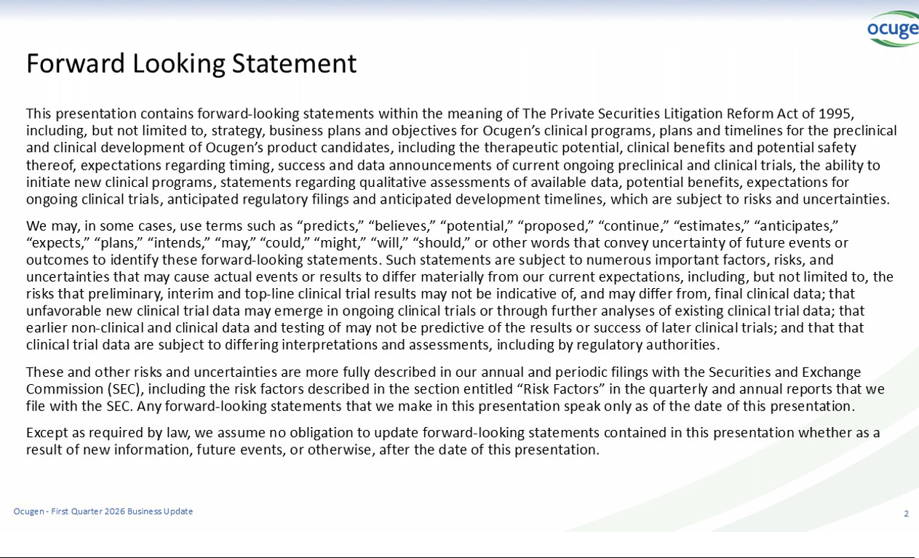

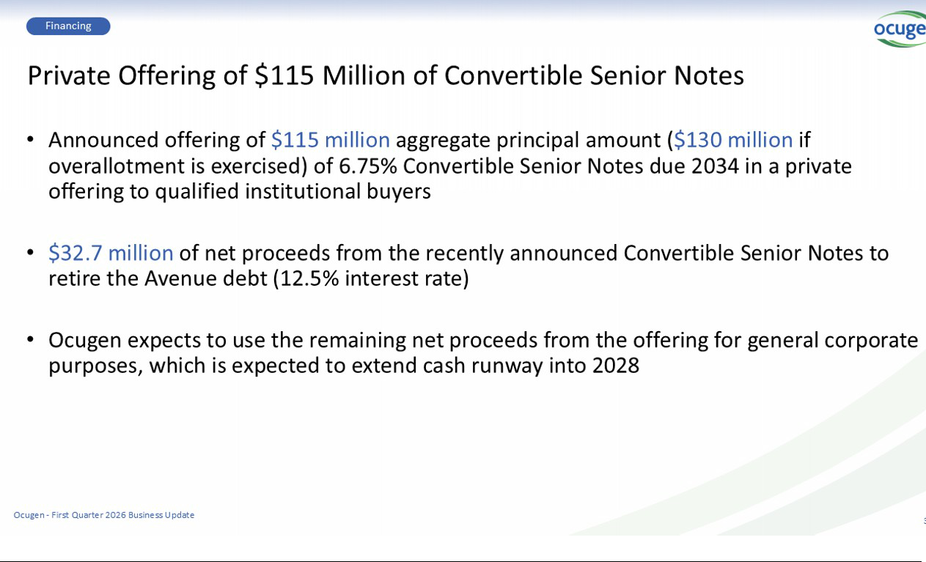

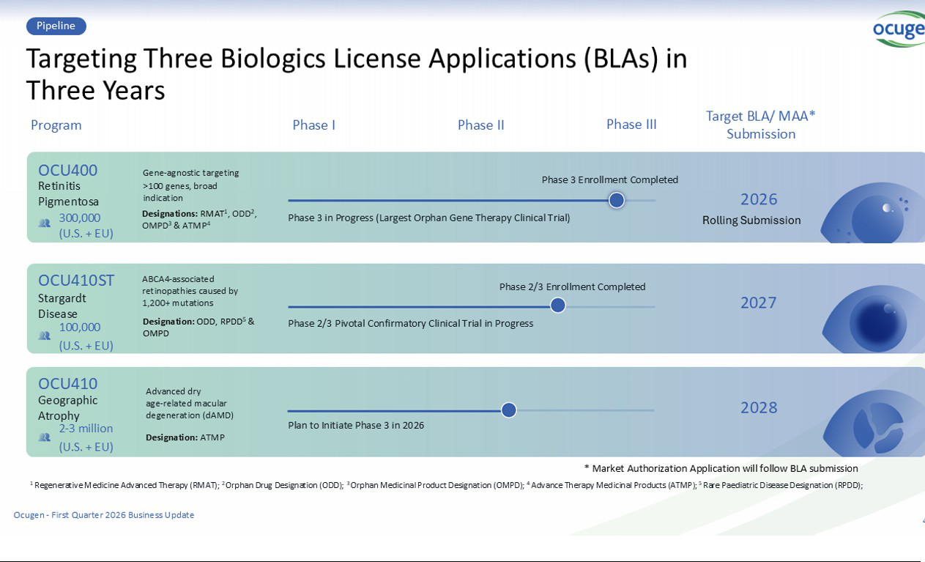

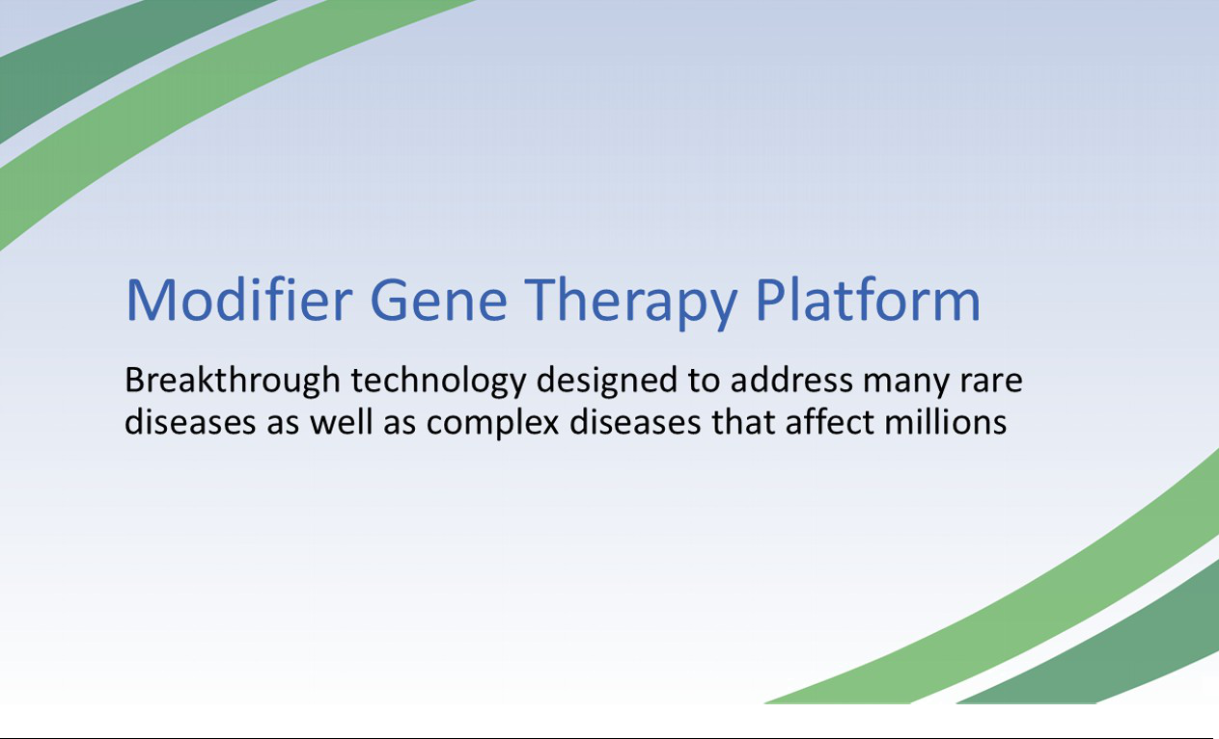

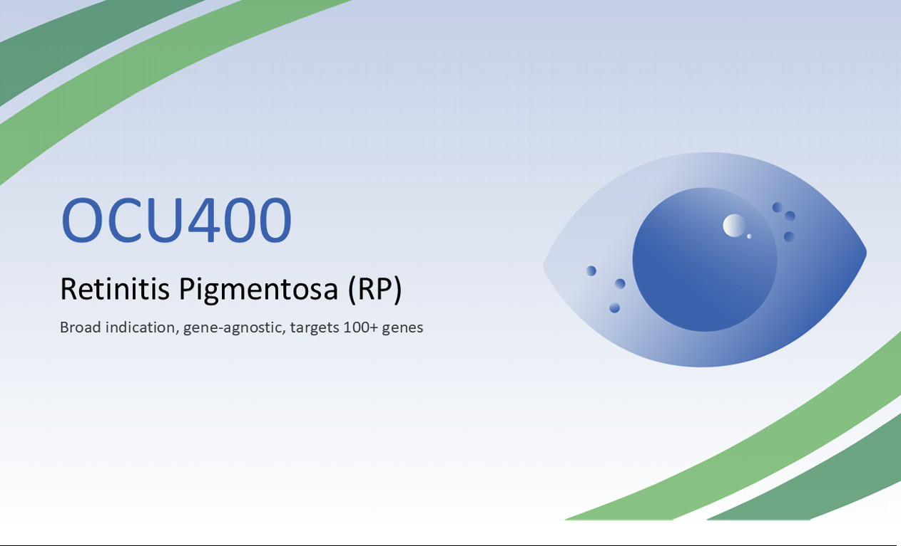

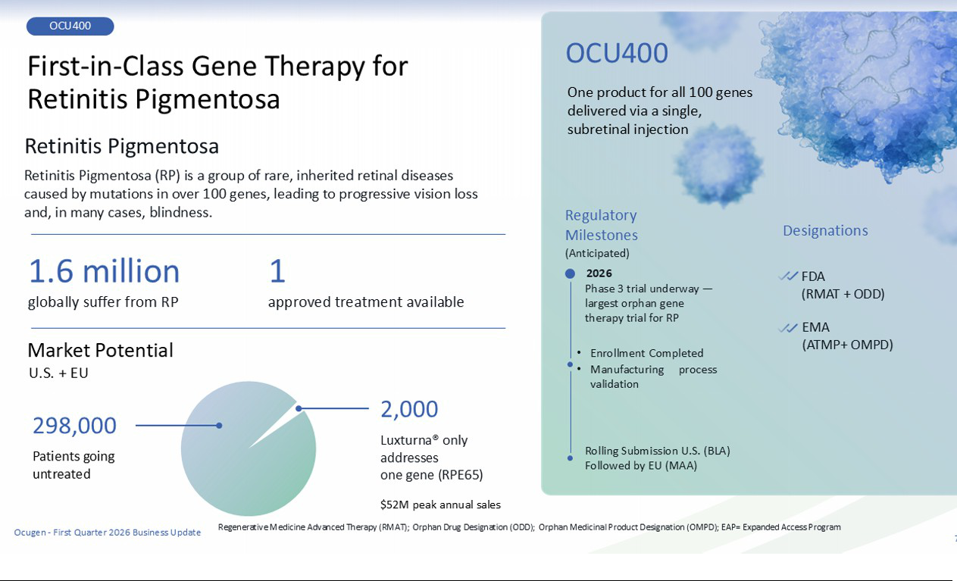

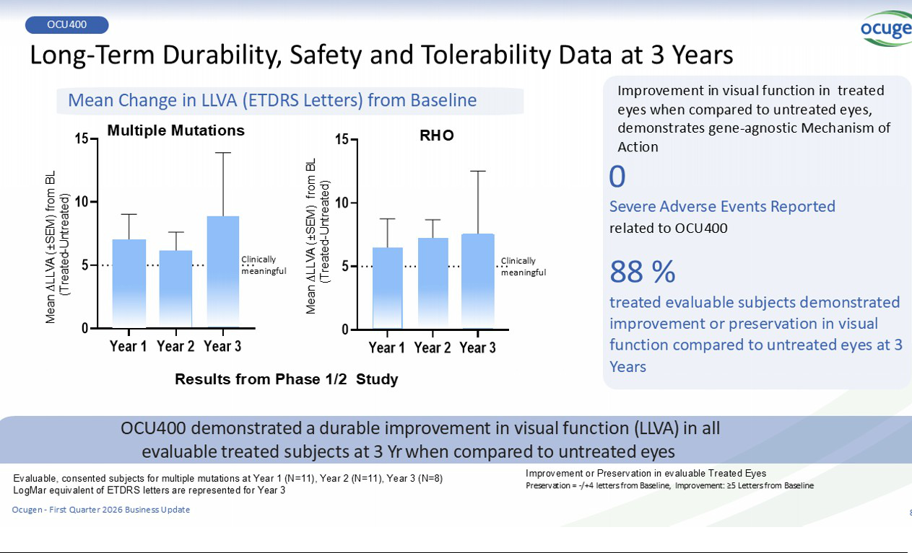

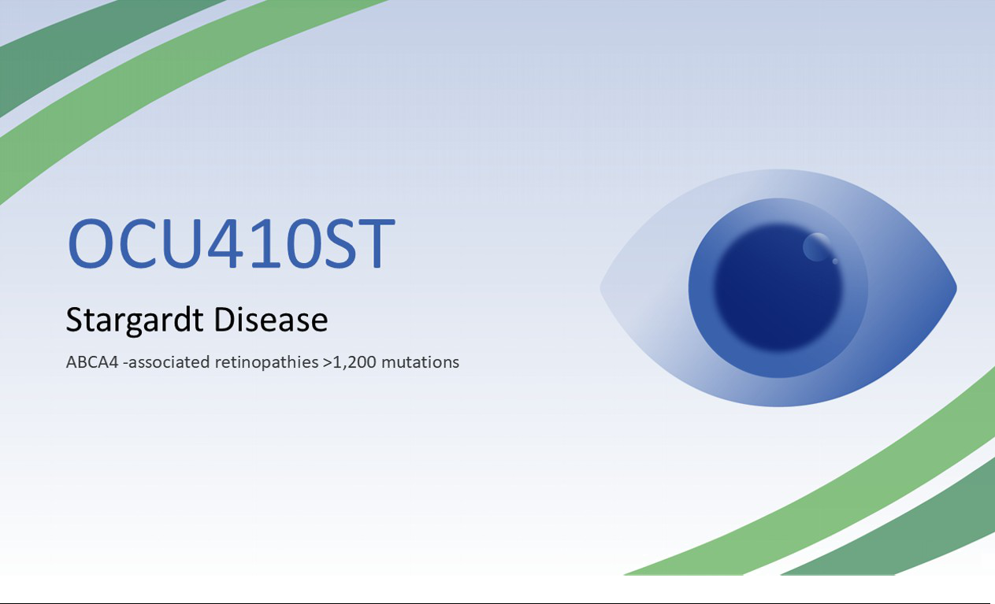

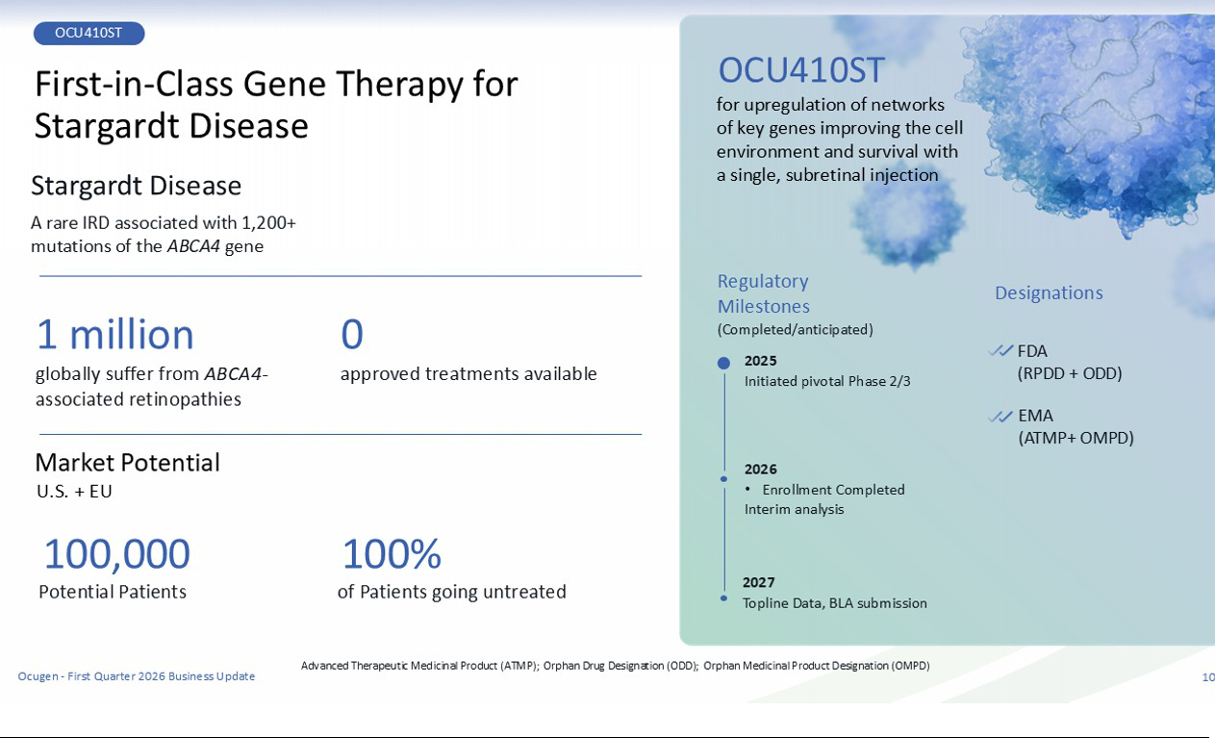

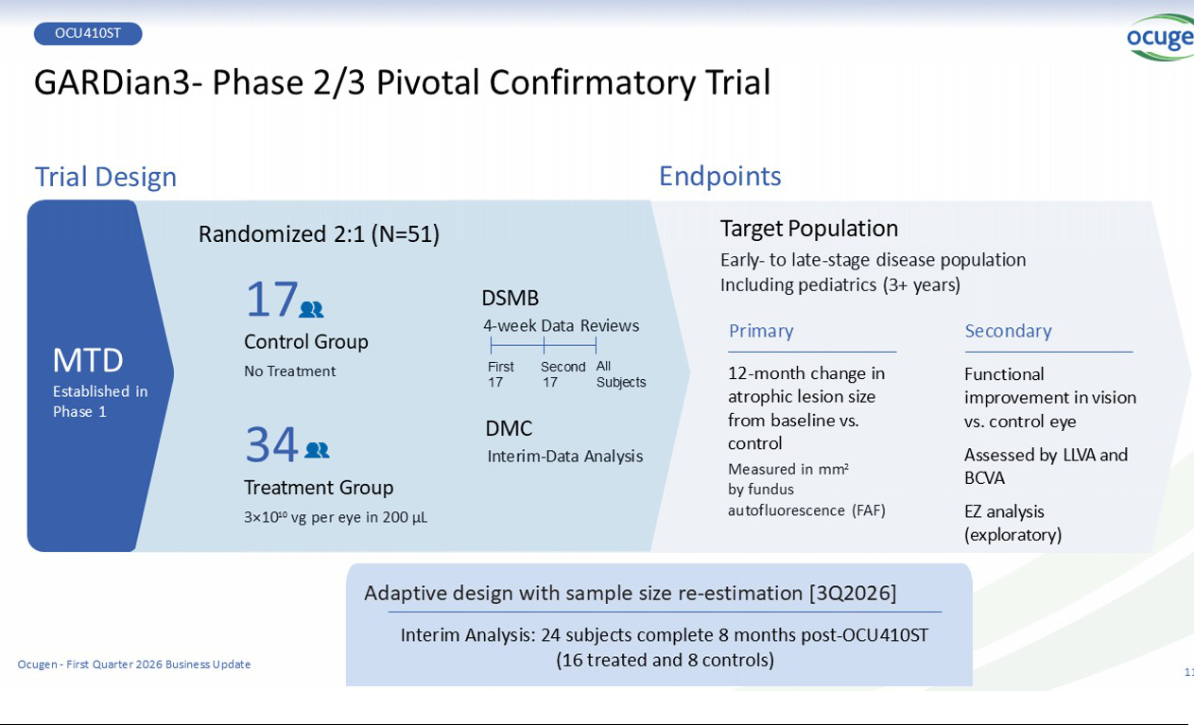

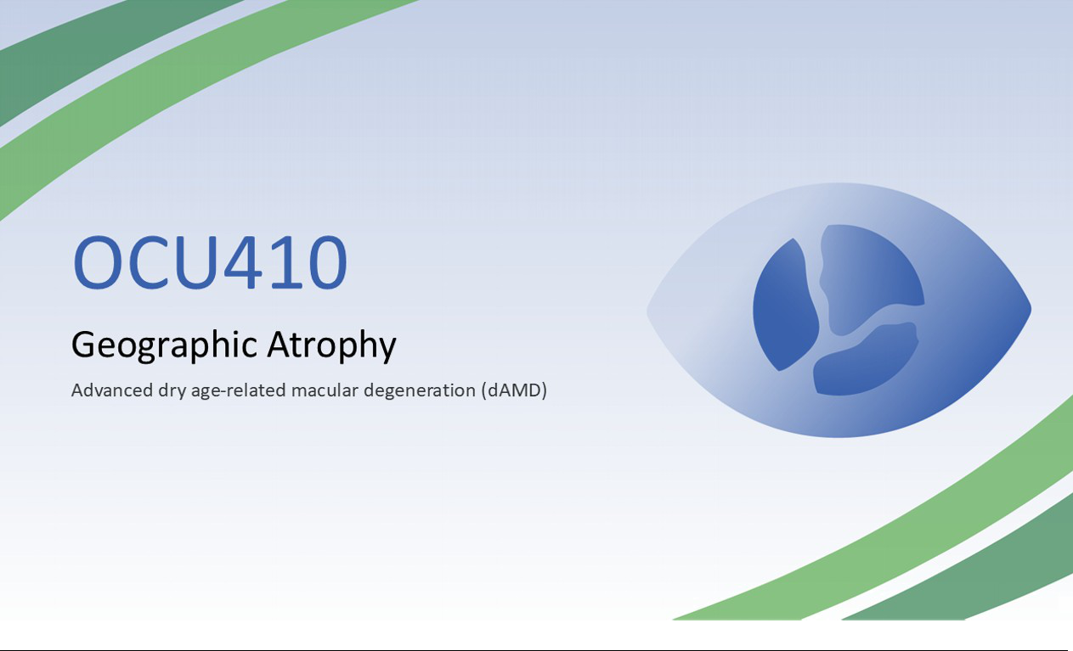

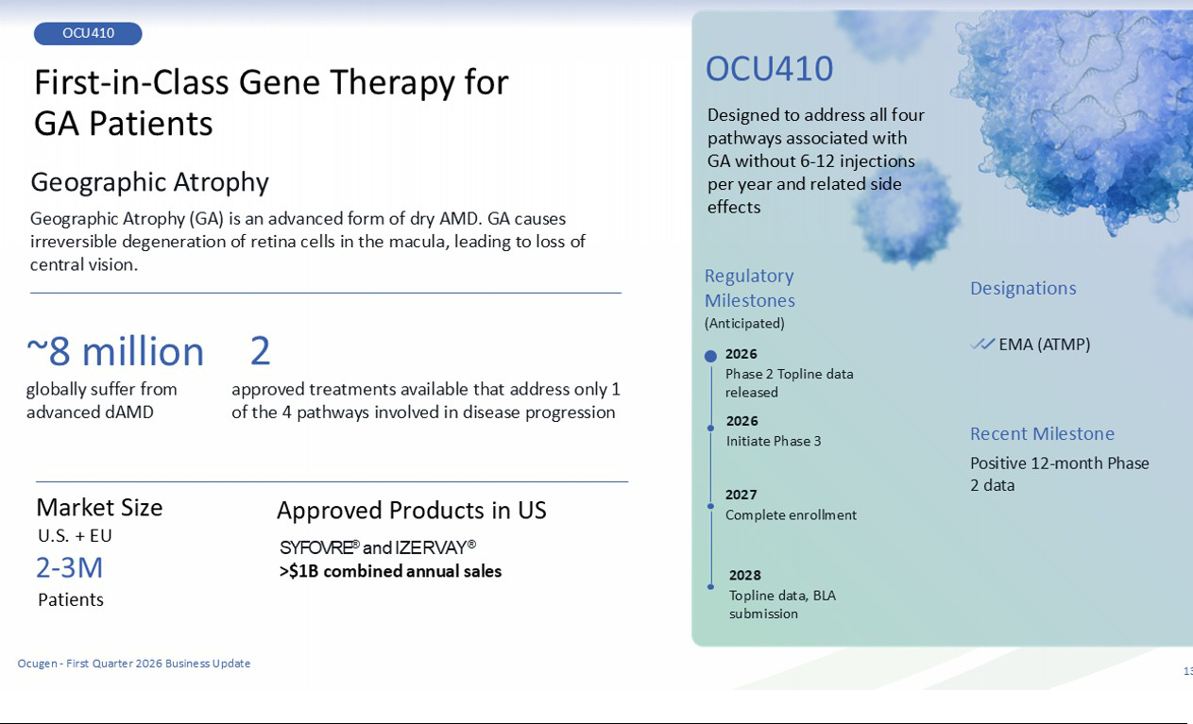

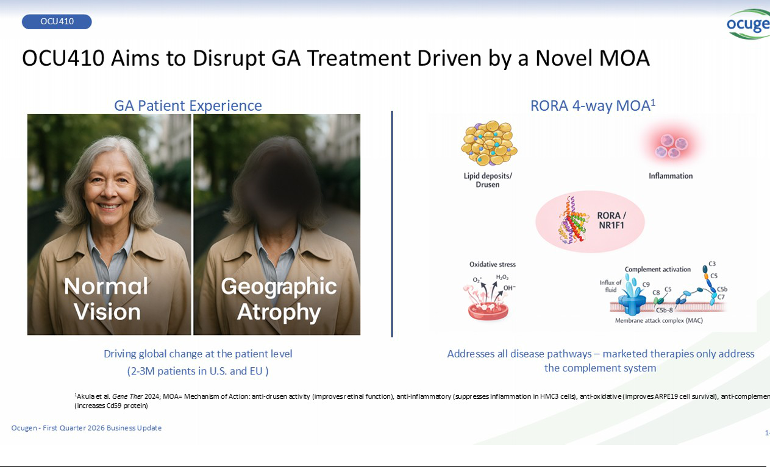

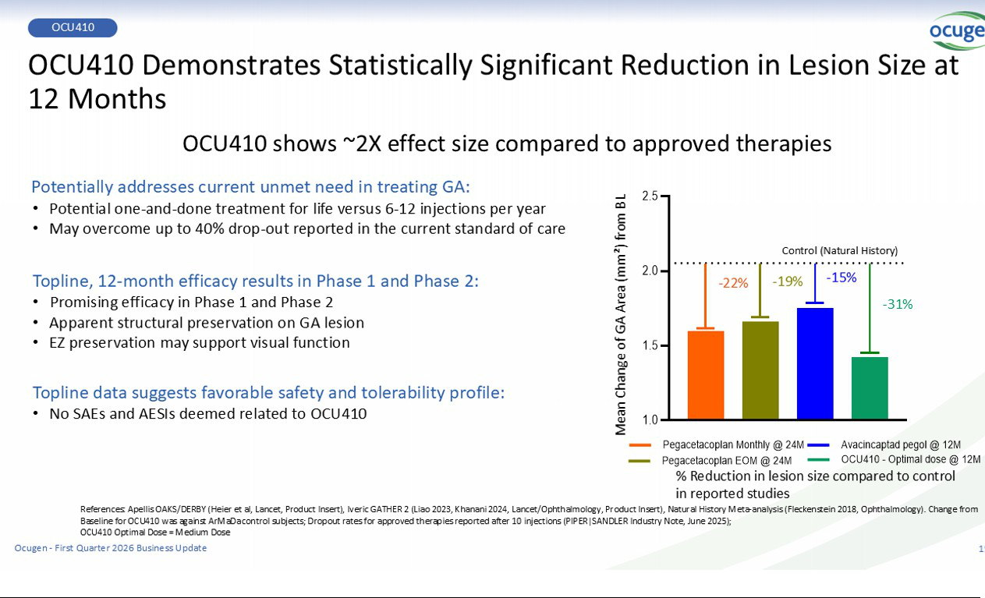

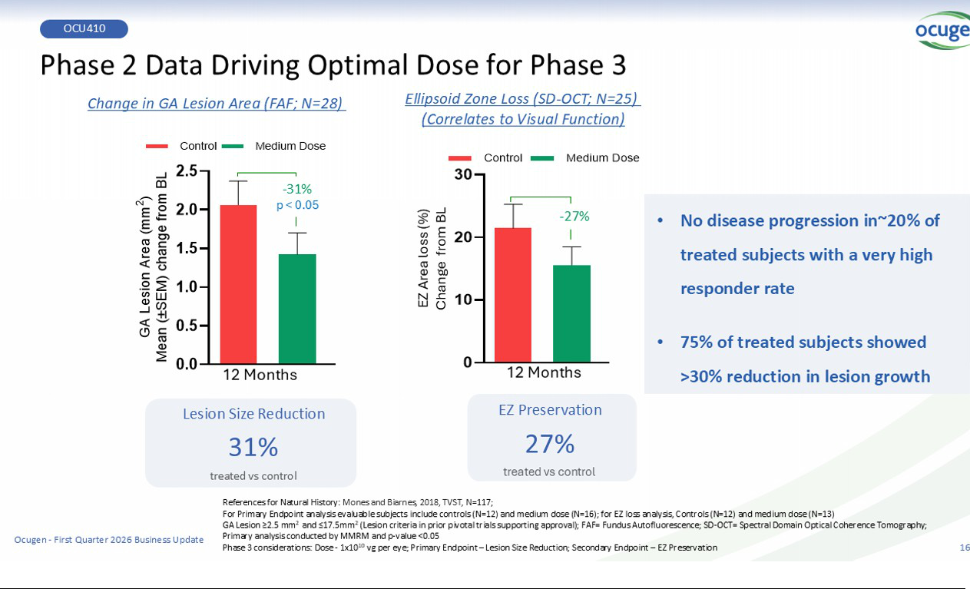

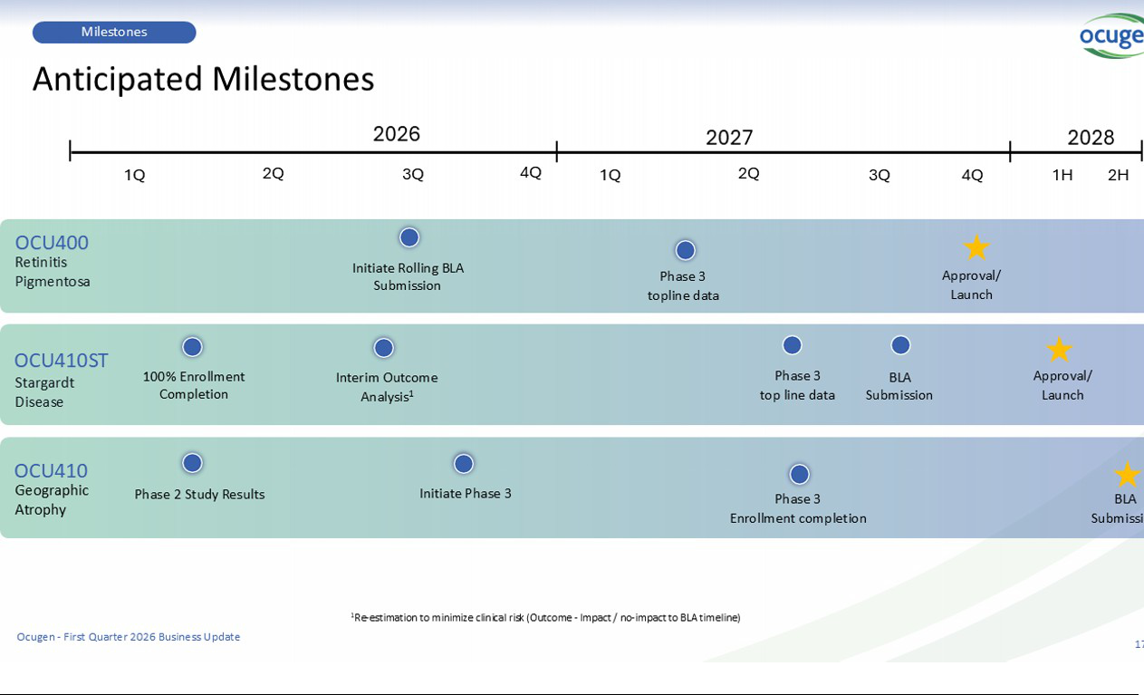

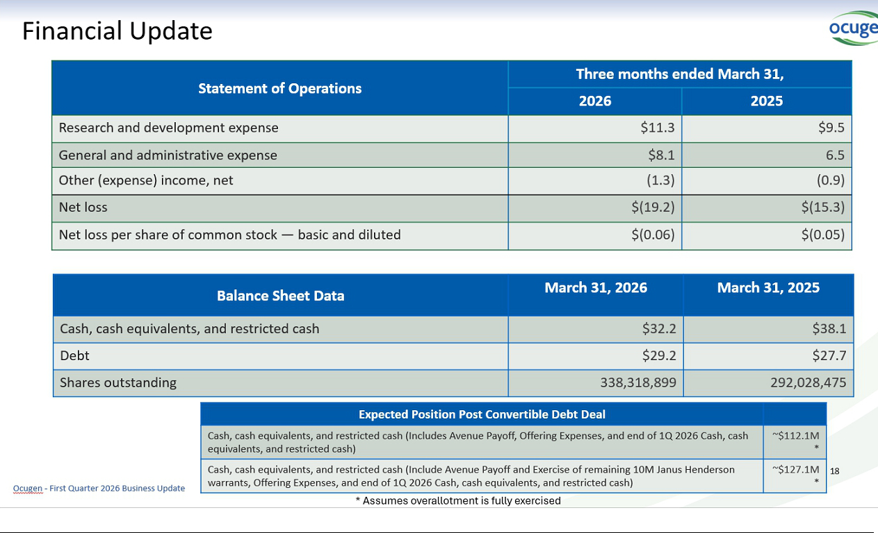





Exhibit 99.3

Ocugen, Inc. Announces Pricing of $115 Million of 6.75% Convertible Senior Notes

MALVERN, Pa., May 5, 2026 (GLOBE NEWSWIRE) — Ocugen, Inc. (“Ocugen”) (NASDAQ: OCGN) today announced the pricing of $115 million aggregate principal amount of 6.75% Convertible Senior Notes due 2034 (the “notes”) in a private offering (the “offering”) to qualified institutional buyers pursuant to Rule 144A under the Securities Act of 1933, as amended (the “Securities Act”). Ocugen also granted the initial purchaser of the notes a 13-day option to purchase up to an additional $15 million aggregate principal amount of the notes. The sale of the notes to the initial purchaser is expected to close on May 7, 2026, subject to customary closing conditions, and is expected to result in approximately $99.5 million (or approximately $112.6 million if the initial purchaser exercises its option to purchase additional notes in full) in net proceeds to Ocugen after deducting the initial purchaser’s discount and estimated offering expenses payable by Ocugen.

The offering price of the notes is 90% of the principal amount of notes. Ocugen intends to use approximately $32.7 million of the net proceeds from the offering to fully repay the outstanding principal amount of, plus accrued and unpaid interest on, the loan outstanding under its Loan and Security Agreement with affiliates of Avenue Capital Group (the “Avenue Loan Agreement”), and pay the related prepayment fee and other fees and expenses in connection therewith. Ocugen expects to use the remaining net proceeds from the offering, including any additional proceeds from the initial purchaser’s exercise of its option to purchase additional notes, for general corporate purposes.

The notes will be Ocugen’s general unsecured obligations and will rank senior in right of payment to all of its future indebtedness that is expressly subordinated in right of payment to the notes, equal in right of payment to all of its existing and future liabilities that are not so subordinated, and junior to all of its secured indebtedness, to the extent of the value of the assets securing such indebtedness. Interest will be payable semi-annually in arrears. The notes will bear interest at a rate of 6.75% per year. Interest will be payable semi-annually in arrears on May 15 and November 15 of each year, beginning on November 15, 2026. The notes will mature on May 15, 2034, unless earlier repurchased, redeemed or converted.

Ocugen may not redeem the notes prior to May 15, 2029. Ocugen may redeem for cash all or any portion of the notes (subject to certain limitations), at its option, on or after May 15, 2029 and prior to the 41st scheduled trading day immediately preceding the maturity date, if the last reported sale price of Ocugen’s common stock has been at least 130% of the conversion price then in effect for at least 20 trading days (whether or not consecutive) during any 30 consecutive trading day period (including the last trading day of such period) ending on, and including, the trading day immediately preceding the date on which Ocugen provides notice of redemption at a redemption price equal to 100% of the principal amount of the notes to be redeemed, plus accrued and unpaid interest to, but excluding, the redemption date. Holders of the notes may require Ocugen to repurchase for cash all or any portion of their notes on May 15, 2032 at a repurchase price equal to 100% of the principal amount of notes to be repurchased, plus accrued and unpaid interest to, but excluding May 15, 2032. In addition, holders of the notes will have the right to require Ocugen to repurchase all or a portion of their notes upon the occurrence of a fundamental change (as defined in the indenture governing the notes) at a purchase price of 100% of their principal amount plus any accrued and unpaid interest to, but excluding, the relevant fundamental change repurchase date.

The notes may not be converted prior to the earlier of (i) May 15, 2027 and (ii) the “reserved share effective date” (as defined in the indenture governing the notes), which is effectively the date on which Ocugen reserves the maximum number of shares of common stock underlying the notes. The notes will be convertible at an initial conversion rate of 372.7866 shares of Ocugen’s common stock per $1,000 principal amount of notes (equivalent to an initial conversion price of approximately $2.68 per share, which represents a conversion premium of approximately 45% to the last reported sale price of $1.85 per share of Ocugen’s common stock on The Nasdaq Capital Market on May 4, 2026). Conversions of the notes may be settled in cash, shares of Ocugen’s common stock, or a combination thereof, at Ocugen’s election; provided that unless and until the reserved share effective date occurs, conversions of the notes will be settled via cash settlement.

The notes were only offered to qualified institutional buyers pursuant to Rule 144A under the Securities Act. Neither the notes nor the shares of Ocugen’s common stock potentially issuable upon conversion of the notes, if any, have been, or will be, registered under the Securities Act or the securities laws of any other jurisdiction, and unless so registered, may not be offered or sold in the United States except pursuant to an applicable exemption from such registration requirements.

This announcement is neither an offer to sell nor a solicitation of an offer to buy any of these securities and shall not constitute an offer, solicitation or sale in any jurisdiction in which such offer, solicitation or sale is unlawful.

Cautionary Note on Forward-Looking Statements

This press release contains forward-looking statements within the meaning of The Private Securities Litigation Reform Act of 1995, which are subject to risks and uncertainties, including but not limited to, statements regarding the anticipated use of proceeds from the offering, including the repayment of the Avenue Loan Agreement; the completion of the offering, and other statements contained in this press release that are not historical facts. Ocugen may, in some cases, use terms such as “predicts,” “believes,” “potential,” “proposed,” “continue,” “estimates,” “anticipates,” “expects,” “plans,” “intends,” “may,” “could,” “might,” “will,” “should,” or other words that convey uncertainty of future events or outcomes to identify these forward-looking statements. Such statements are subject to numerous important factors, risks, and uncertainties that may cause actual events or results to differ materially from Ocugen’s current expectations, including, but not limited to: risks related to the offering and uncertainties related to market conditions; the impact of the offering on the market price of Ocugen’s common stock; and risks related to the potential dilution to holders of Ocugen’s common stock. These and other risks and uncertainties are more fully described in Ocugen’s periodic filings with the Securities and Exchange Commission (SEC), including the risk factors described in the section entitled “Risk Factors” in the quarterly and annual reports that Ocugen files with the SEC. Any forward-looking statements that Ocugen makes in this press release speak only as of the date of this press release. Except as required by law, Ocugen assumes no obligation to update forward-looking statements contained in this press release whether as a result of new information, future events, or otherwise, after the date of this press release

Contact:

Candice Masse

astr partners

candice.masse@astrpartners.com

