TABLE OF CONTENTS
UNITED STATES
SECURITIES AND EXCHANGE COMMISSION
Washington, D.C. 20549
SCHEDULE 14A
Proxy Statement Pursuant to Section 14(a) of
the Securities Exchange Act of 1934
Filed by the Registrant ☒
Filed by a party other than the Registrant ☐
Check the appropriate box:
☐ Preliminary Proxy Statement
☐ Confidential, for Use of the Commission Only (as permitted by Rule 14a-6(e)(2))
☒ Definitive Proxy Statement
☐ Definitive Additional Materials
☐ Soliciting Material under §240.14a-12


Ocugen, Inc.
(Name of Registrant as Specified in Its Charter)
(Name of Person(s) Filing Proxy Statement, if other than the Registrant)
Payment of Filing Fee (Check all boxes that apply):
☒ No fee required
☐ Fee paid previously with preliminary materials
☐ Fee computed on table in exhibit required by Item 25(b) per Exchange Act Rules 14a-6(i)(1) and 0-11

TABLE OF CONTENTS


TABLE OF CONTENTS


11 Great Valley Parkway
Malvern, PA 19355
SPECIAL MEETING OF STOCKHOLDERS
To Be Held on September 21, 2026
July 30, 2026
DEAR STOCKHOLDER:
As we continue advancing our mission to bring transformative gene therapies to patients with significant unmet medical needs, I want to thank you for your ongoing support and confidence in Ocugen.
Over the past several months, we have achieved important milestones that have strengthened our company and positioned us for future growth, including:
• | Successfully raising capital to pay off high-interest debt and extend our cash runway.
• | Securing a partnership with Roots Pharmaceutical to license OCU400 for retinitis pigmentosa in the Middle East and North Africa – further validating both our modifier gene therapy platform and regional partnership strategy.
• | Advancing discussions with the FDA and other health authorities to align on the Phase 3 study design for our Geographic Atrophy program (OCU410).
As the Company enters a critical stage of growth, we are asking shareholders to approve an amendment to our charter to increase the number of authorized shares of common stock by 250,000,000 shares.
This request reflects our commitment to creating long-term value for both patients and shareholders. We recognize that authorizing additional shares raises concerns about potential dilution, which is why we remain focused on pursuing partnerships and other alternative sources of capital that can support our growth while reducing reliance on equity financing.
We have made considerable progress, and with plans for three BLA submissions by 2028, we are closer than ever to becoming a commercial-stage biotechnology company. With your continued support, we can build on this momentum and create meaningful value for patients, shareholders, and all stakeholders.
On behalf of our Board of Directors and the entire Ocugen team, I encourage you to support the proposal to increase the number of authorized shares of common stock.
Thank you for your continued trust and partnership.
Sincerely,
​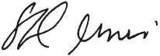

Shankar Musunuri, Ph.D., MBA
Chairman of the Board, Chief Executive Officer and Co-Founder of Ocugen

TABLE OF CONTENTS
This letter contains forward-looking statements with respect to Ocugen’s financial condition, business and prospects. Forward-looking statements can be identified by the use of such words as “may,” “should,” “will,” “could,” “estimates,” “predicts,” “potential, “continue,” “anticipates,” “believes,” “plans,” “expects,” “future,” “intends,” “projects,” the negative of these terms and other comparable terminology. These forward-looking statements may include projections of, or guidance on, Ocugen’s future financial performance and cash runway, anticipated growth strategies, financing and partnership strategies, expectations regarding the definitive license and supply agreement to be entered into with Roots Pharmaceutical, timing of BLA submissions, descriptions of business initiatives and anticipated trends in Ocugen’s business or financial results.
Forward-looking statements are neither historical facts, nor assurance of future performance. Instead, these statements are based on current beliefs, expectations and assumptions regarding Ocugen’s business, strategies, projections, as well as anticipated events and trends. Forward-looking statements are subject to inherent uncertainties, risks and changes in circumstances that are difficult to predict and many of which are outside of Ocugen’s control, and Ocugen’s actual results and financial condition may differ materially from those indicated in the forward-looking statements. Therefore, you should not unduly rely on any of these forward-looking statements. Any forward-looking statement is based only on information currently available and speaks only as of the date when made. Ocugen undertakes no obligation, other than as required by law, to update or revise any forward-looking statements, whether as a result of new information, future events or otherwise.
A discussion of certain risks and uncertainties affecting Ocugen, and some of the factors that could cause Ocugen’s actual results to differ materially from those described in the forward-looking statements, can be found in the sections entitled “Risk Factors” and “Management’s Discussion and Analysis of Financial Condition and Results of Operations” in Ocugen’s Annual Report on Form 10-K for the year ended December 31, 2025 and Ocugen’s Quarterly Report on Form 10-Q for the quarter ended March 31, 2026.

TABLE OF CONTENTS
TABLE OF CONTENTS

NOTICE OF SPECIAL MEETING
PROXY DASHBOARD
PROPOSAL 1— APPROVAL OF THE ADOPTION OF AN AMENDMENT TO OUR CHARTER TO INCREASE THE NUMBER OF AUTHORIZED SHARES OF COMMON STOCK BY 250,000,000 SHARES |  |  |  |  |  | 1
PROPOSAL 2—APPROVAL OF ADJOURNMENT OF THE SPECIAL MEETING TO SOLICIT ADDITIONAL PROXIES IF THERE ARE INSUFFICIENT VOTES |  |  |  |  |  | 5
 |  |  | SECURITY OWNERSHIP OF CERTAIN BENEFICIAL OWNERS AND MANAGEMENT |  |  | 7
GENERAL INFORMATION |  |  |  |  |  | 9

TABLE OF CONTENTS
NOTICE OF SPECIAL MEETING
DEAR STOCKHOLDER:
You are invited to attend Ocugen, Inc.’s (the “Company,” “us,” “we,” “our,” or “Ocugen”) Special Meeting of Stockholders (the “Special Meeting”) on Monday, September 21, 2026, at 8 a.m., Eastern Time.
This Special Meeting will be a completely virtual meeting of stockholders, which will be conducted via a live audio webcast. You will be able to attend the Special Meeting online, vote electronically and submit your questions during the meeting by visiting www.virtualshareholdermeeting.com/OCGN2026SM.
At the Special Meeting, stockholders will vote on:
1. | Approval of the adoption of an amendment to Ocugen, Inc.’s Sixth Amended and Restated Certificate of Incorporation, as amended (the “Charter”), to increase the number of authorized shares of common stock by 250,000,000 shares (“Proposal 1”).
2. | Approval of an adjournment of the Special Meeting, if necessary or appropriate, to solicit additional proxies if there are insufficient votes at the time of the Special Meeting to approve Proposal 1 (the “Adjournment Proposal”).
VOTING
You are entitled to notice of the Special Meeting and to vote at the Special Meeting and any adjournments or postponements thereof only if you were a stockholder as of the close of business on July 27, 2026 (the “Record Date”).
STOCKHOLDER COMMUNICATION
The board of directors (the “Board”) will give appropriate attention to written communications that are submitted by stockholders and other interested parties and will respond if and as appropriate.
​How to Communicate  with our Directors |  |  | By mail:  The Corporate Secretary  Ocugen, Inc.  11 Great Valley Parkway  Malvern, PA 19355

TABLE OF CONTENTS
PROXY STATEMENT
We are pleased to comply with the rules of the Securities and Exchange Commission (the “SEC”) that allow companies to distribute their proxy materials over the Internet under the “notice and access” approach. As a result, we are mailing to many stockholders a Notice of Internet Availability of Proxy Materials for the Special Meeting to Be Held on September 21, 2026 (the “Notice of Availability”) instead of a paper copy of our proxy materials. We will mail the Notice of Availability or the Notice of the Special Meeting, this proxy statement (the “Proxy Statement”) and a form of the proxy card on or about July 30, 2026. The Notice of Availability contains instructions on how to access proxy materials online and to cast your vote or submit a proxy over the Internet. This process will allow us to reduce the environmental impact and lower the costs of printing and distributing our proxy materials. If you have received the Notice of Availability, but would like to receive a printed copy of our proxy materials, including the Notice of the Special Meeting, our proxy statement, and a form of proxy card, free of charge, please follow the instructions on the Notice of Availability. This Proxy Statement is also available on the SEC’s website at www.sec.gov. The Special Meeting will be held virtually via live webcast on Monday, September 21, 2026, at 8 a.m., Eastern Time.
IMPORTANT NOTICE REGARDING THE AVAILABILITY OF PROXY MATERIALS FOR THE SPECIAL MEETING TO BE HELD ON SEPTEMBER 21, 2026. THE NOTICE OF THE SPECIAL MEETING, THIS PROXY STATEMENT, AND THE ENCLOSED PROXY CARD ARE FIRST BEING MADE AVAILABLE OR MAILED TO OUR STOCKHOLDERS ON OR ABOUT JULY 30, 2026. IN ACCORDANCE WITH THE SEC RULES THAT ALLOW COMPANIES TO FURNISH PROXY MATERIALS TO THEIR STOCKHOLDERS OVER THE INTERNET, WE MAIL TO MANY STOCKHOLDERS A NOTICE OF INTERNET AVAILABILITY OF PROXY MATERIALS RATHER THAN A PAPER COPY OF OUR PROXY MATERIALS RELATED TO OUR FORTHCOMING SPECIAL MEETING. THE NOTICE OF THE SPECIAL MEETING AND THIS PROXY STATEMENT ARE AVAILABLE TO HOLDERS OF OUR COMMON STOCK AT WWW.PROXYVOTE.COM.

TABLE OF CONTENTS
USER’S GUIDE
PROXY DASHBOARD
To assist you in reviewing these proposals, we call your attention to the following proxy summary. This is only a summary; please review this Proxy Statement in full.
GENERAL INFORMATION
Meeting Date: |  |  | Time: |  |  | Location: |  |  | Record Date:
Monday, September 21, 2026 |  |  | 8 a.m., ET |  |  | The meeting can be accessed by visiting www.virtualshareholdermeeting.com/  OCGN2026SM, where you will be able to listen to the meeting live, submit questions, and vote online. There will be no physical location for stockholders to attend. |  |  | July 27, 2026
VOTING MATTERS AND VOTING RECOMMENDATIONS
 | ​ |  |  | Matters |  |  | Board Vote Recommendation
 | 1 |  |  | Approval of the adoption of an amendment to the Charter to increase the number of authorized shares of common stock by 250,000,000 shares |  |  | FOR  
 | 2 |  |  | Approval of an adjournment of the Special Meeting, if necessary or appropriate, to solicit additional proxies if there are insufficient votes at the time of the Special Meeting to approve Proposal 1 |  |  | FOR  

TABLE OF CONTENTS

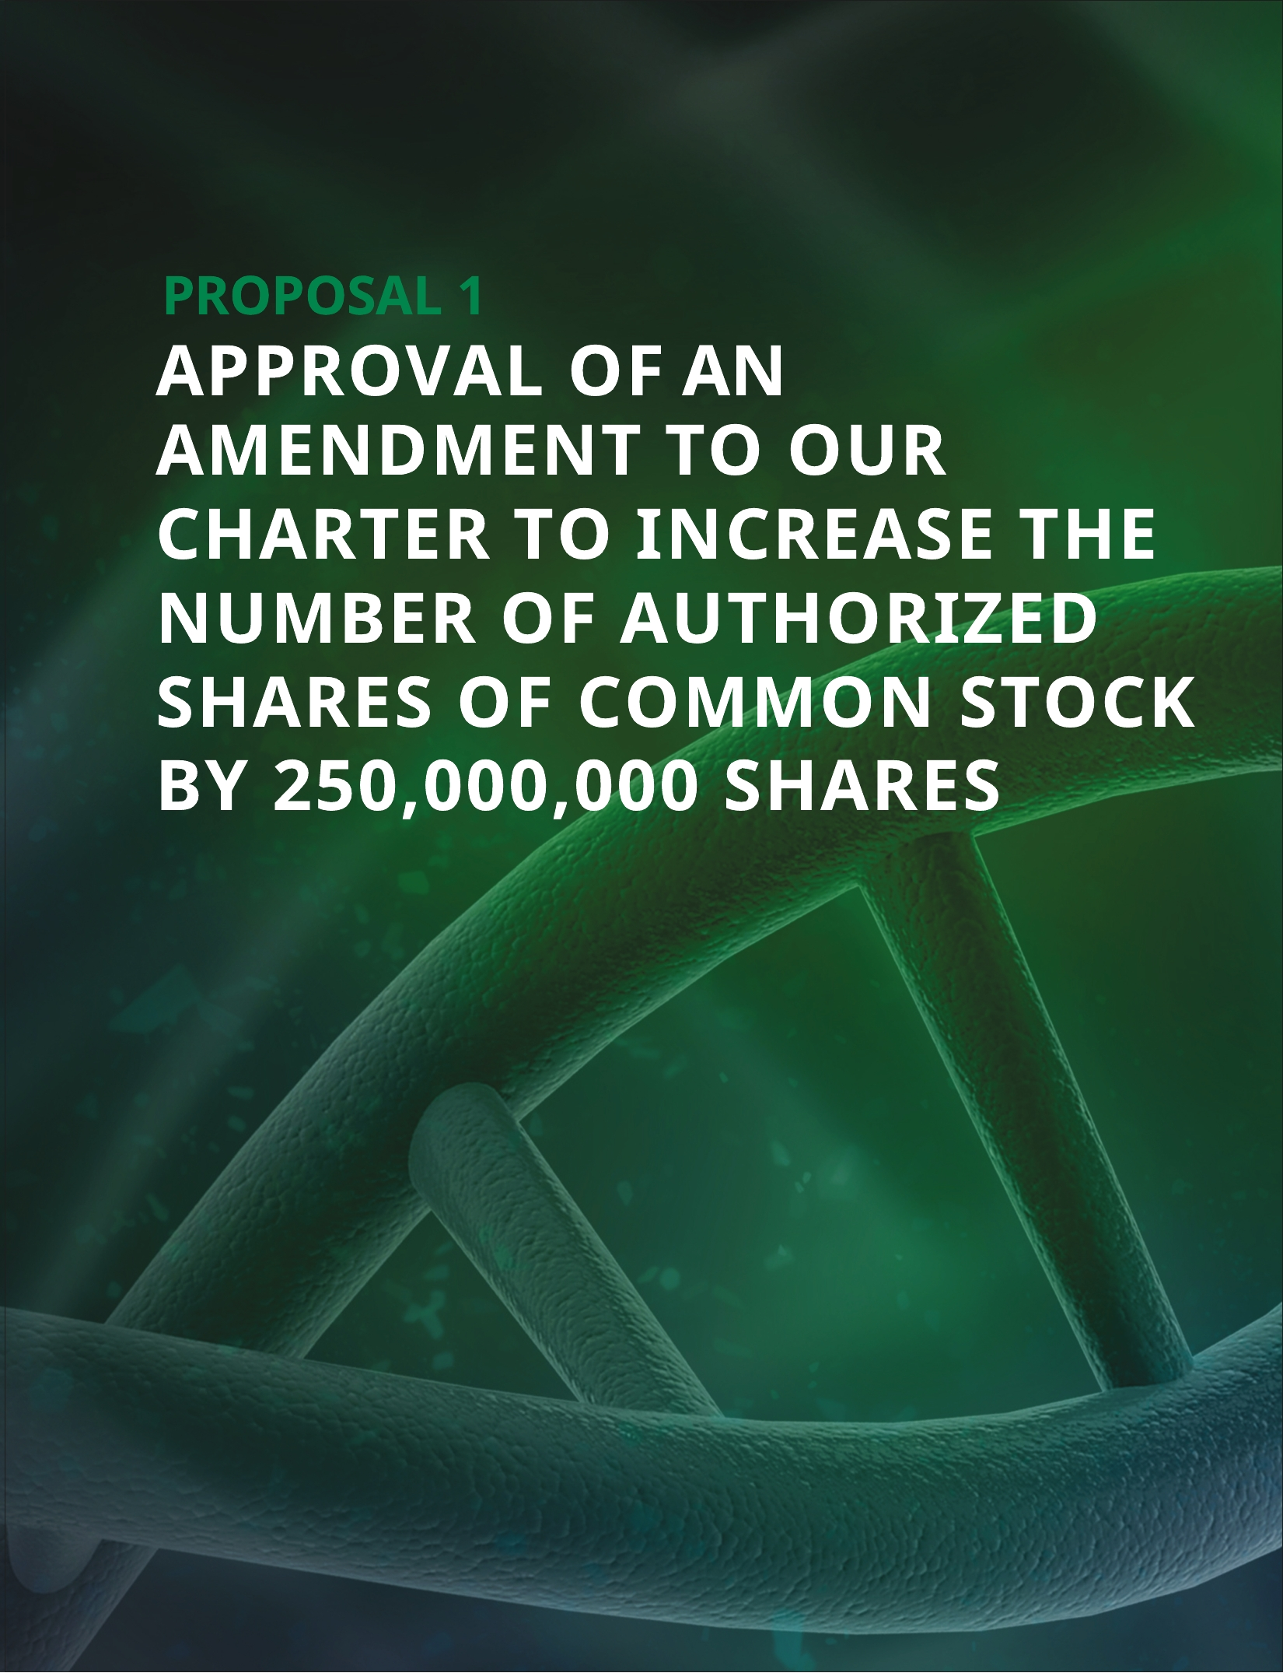

TABLE OF CONTENTS
BACKGROUND
The Board has unanimously approved, subject to stockholder approval, an amendment to our Charter to increase the number of authorized shares of common stock by 250,000,000 shares of common stock, from 390,000,000 to 640,000,000 shares of common stock (the “Authorized Shares Amendment”). The Authorized Shares Amendment will not change the number of authorized shares of preferred stock, which currently consists of 10,000,000 shares of preferred stock. The additional shares of common stock authorized for issuance by the Authorized Shares Amendment would be a part of the existing class of common stock and, if and when issued, would have the same rights, powers and privileges as the common stock presently issued and outstanding. As of the Record Date, we had 339,110,401 shares of common stock issued and outstanding.
Provided the stockholders approve the adoption of the Authorized Shares Amendment, the increased number of shares would be authorized for issuance, but would remain unissued until such time as the Board approves an issuance of those shares. Adoption of the Authorized Shares Amendment would not affect the rights of the holders of currently outstanding common stock, except for effects incidental to increasing the number of shares of our common stock outstanding, such as dilution of the earnings per share and voting rights of current holders of common stock, to the extent that any additional shares of common stock are ultimately issued out of the increase in authorized shares proposed in the Authorized Shares Amendment.
If the proposed Authorized Shares Amendment is adopted and approved by the requisite vote of the stockholders, it will become effective upon the filing of a Certificate of Amendment with the Secretary of State of the State of Delaware or such later effective time as may be provided therein (the “Certificate of Amendment”). On July 16, 2026, our Board determined that the proposed Authorized Shares Amendment is advisable and in the best interests of the Company and our stockholders and authorized and approved the proposed Authorized Shares Amendment, subject to stockholder approval, and recommended it to our stockholders for adoption, and directed that it be considered, at the Special Meeting.
The proposed Certificate of Amendment reflecting the Authorized Shares Amendment is attached as Appendix A to this Proxy Statement, subject to such ministerial changes as may be required by the Secretary of State of the State of Delaware.
PURPOSES AND EFFECTS OF THE AUTHORIZED SHARES AMENDMENT
The ability to issue equity is fundamental to our growth strategy. In order to implement our growth strategy, we may need to obtain financing through the issuance of equity securities. The availability of equity incentive compensation is necessary for us to attract, retain and motivate the most high-performing executives and key employees who ultimately drive our performance. The Board is recommending the proposed increase in the authorized number of shares of common stock to provide us with appropriate flexibility to issue additional shares in the future on a timely basis if such need arises in connection with potential financings, business combinations, licensing arrangements or other corporate purposes. Approval and adoption of the Authorized Shares Amendment could enable us to take advantage of market conditions, the availability of more favorable financing, and opportunities for business combinations and other strategic transactions, without the potential delay and expense associated with convening a special stockholders’ meeting. Our success also depends in part on our continued ability to attract, retain and motivate highly qualified management and key personnel, and the approval and adoption of the Authorized Shares Amendment would ensure that there is no lack of unissued and unreserved authorized shares of common stock to provide equity incentive opportunities.
In addition, as previously disclosed, in May 2026, we completed a private offering of $130.0 million in aggregate principal amount of 6.75% convertible senior notes due 2034 (the “Notes”) that were issued pursuant to an indenture between us and U.S. Bank Trust Company, National Association as trustee (the “Indenture”). Under the terms of the Indenture, we agreed to hold a stockholders’ meeting no later than September 30, 2026 to obtain stockholder approval for either an increase in our authorized shares of common stock or a reverse stock split, in each case that would result in a number of authorized and unissued shares of common stock at least sufficient to cover the maximum number of shares that may be issued upon conversion of the Notes (the “reserved share effective date”). If we do not obtain the stockholder approval of the Authorized Shares Amendment on or prior to September 30, 2026, we are obligated to use our best efforts to obtain such approval as soon as possible. The Notes may not be converted prior to the earlier of (i) May 15, 2027 and (ii) the reserved
2 | Notice of Special Meeting of Stockholders and Proxy Statement

TABLE OF CONTENTS
share effective date. On or after such date, the Notes will be convertible at the option of the holders at any time prior to the close of business on the second scheduled trading day immediately preceding the maturity date. Upon conversion, we will pay or deliver, as the case may be, cash, shares of our common stock, or a combination of cash and shares of common stock, at our election, subject to the terms of the Notes and the Indenture; provided that unless and until the reserved share effective date occurs, we will settle conversion of Notes solely with cash.
The proposed Authorized Shares Amendment will not, by itself, have an immediate dilutive effect on our current stockholders. However, if the Authorized Shares Amendment is approved and adopted by our stockholders, unless otherwise required by applicable law or stock exchange rules, the Board will be able to issue the additional shares of common stock from time to time in its discretion without further action or authorization by the stockholders, including upon the conversion of the Notes into shares of common stock. The newly authorized shares of common stock would be issuable for any proper corporate purpose, including capital raising transactions of equity or convertible debt securities, the establishment of collaborations or other strategic agreements, stock splits, stock dividends, issuance under current or future equity incentive plans, future acquisitions, investment opportunities, or for other corporate purposes. The future issuance of additional shares of common stock or securities convertible into or exercisable for our common stock may occur at times or under circumstances that could result in a dilutive effect on the earnings per share, book value per share, voting power and percentage interest of the holders of our common stock.
If the stockholders do not approve this Proposal 1, then we will not have the needed additional shares available for our corporate purposes, as discussed above. Approval of this Proposal 1 would also ensure that we will have the option to settle conversion of the Notes in shares of common stock instead of cash, or a combination of cash and shares of common stock, in each case at our election, subject to terms of the Notes and the Indenture. Additionally, if this Proposal 1 is not approved, we will be required under the Indenture to use our best efforts to continue to seek stockholder approval of an increase to our authorized shares of common stock or a reverse stock split.
POTENTIAL ANTI-TAKEOVER EFFECT
Release No. 34-15230 of the staff of the SEC requires disclosure and discussion of the effects of any action, including the proposal discussed herein, that may be used as an anti-takeover mechanism. An increase in the number of authorized shares of common stock may also, under certain circumstances, be construed as having an anti-takeover effect. Although not designed or intended for such purposes, the effect of the proposed increase might be to render more difficult or to discourage a merger, tender offer, proxy contest or change in control of us and the removal of management, which stockholders might otherwise deem favorable. For example, the authority of the Board to issue common stock might be used to create voting impediments or to frustrate an attempt by another person or entity to effect a takeover or otherwise gain control of us because the issuance of additional common stock would dilute the voting power of the common stock then outstanding. Our common stock could also be issued to purchasers who would support the Board in opposing a takeover bid which our Board determines not to be in our best interests and those of our stockholders. Although the Authorized Shares Amendment has been prompted by business and financial considerations and not by the threat of any known or threatened hostile takeover attempt, stockholders should be aware that the effect of the Authorized Shares Amendment could facilitate future attempts by us to oppose changes in control and perpetuate our management, including transactions in which the stockholders might otherwise receive a premium for their shares over then current market prices. We cannot provide assurances that any such transactions will be consummated on favorable terms or at all, that they will enhance stockholder value, or that they will not adversely affect our business or the trading price of the common stock.
The Authorized Shares Amendment is not being proposed in response to any effort, of which we are aware, to accumulate shares of common stock or obtain control of the Company. While it is possible that our management could use the Authorized Shares Amendment to resist or frustrate a third-party transaction providing an above-market premium that is favored by a majority of stockholders, we do not intend to construct or enable any anti-takeover defense or mechanism on its behalf. We have no current intent or plans to employ the Authorized Shares Amendment as an anti-takeover device and do not have any plans or proposals to adopt any other provisions or enter into other arrangements that may have material anti-takeover consequences.
Notice of Special Meeting of Stockholders and Proxy Statement | 3

TABLE OF CONTENTS
In addition to the Authorized Shares Amendment, provisions of our governing documents and applicable provisions of Delaware law may also have anti-takeover effects, making it more difficult for, or preventing a third-party from acquiring control of the Company or changing our Board and management. These provisions may also have the effect of deterring hostile takeovers or delaying changes in our control or in our management.
Our Charter and Bylaws do not provide for cumulative voting in the election of directors, which may make it more difficult for other stockholders to replace the members of the Board or for another party to obtain control of the Company by replacing our Board.
INTERESTS OF DIRECTORS AND EXECUTIVE OFFICERS
As previously disclosed, on January 20, 2026, we entered into a letter agreement with Dr. Musunuri, our Chairman and Chief Executive Officer, that requires us to use our best efforts to obtain stockholder approval and adoption of an amendment to our Charter such as the Authorized Shares Amendment, by December 31, 2026. In the event that we do not receive stockholder approval of the adoption of the Authorized Shares Amendment or a similar Charter amendment by that date, Dr. Musunuri will be entitled to settle certain PSUs and stock options in cash upon vesting and exercise, as applicable, and we would be required to pay interest on the cash settlement amounts as well as a tax gross-up.
Except for the Letter Agreement with Dr. Musunuri, our directors and executive officers have no interests, directly or indirectly, in this Proposal 1 other than to the extent of their ownership of shares of our common stock.
TIMING AND EFFECT OF THE AUTHORIZED SHARES AMENDMENT
If the proposed Authorized Shares Amendment is approved and adopted by our stockholders, it will become effective immediately upon the filing of the Certificate of Amendment with the Secretary of State of the State of Delaware, which we expect to file promptly after the Special Meeting, or such later effective time as may be provided in the Certificate of Amendment. Other than the proposed amendment of Article IV containing the Authorized Shares Amendment, the remainder of our Charter will remain unchanged after effectiveness of the Authorized Shares Amendment.
If the proposed Authorized Shares Amendment is not approved and adopted by our stockholders, our Charter will not reflect this change. In accordance with the DGCL, the Board may elect to abandon the proposed Authorized Shares Amendment without further action by the stockholders at any time prior to the effectiveness of the filing of the Certificate of Amendment effecting the Authorized Shares Amendment with the Secretary of State of the State of Delaware, notwithstanding stockholder approval and adoption of the proposed Authorized Shares Amendment.
 | ​​ THE BOARD UNANIMOUSLY RECOMMENDS A VOTE FOR THE ADOPTION OF AN AMENDMENT TO OUR CHARTER TO INCREASE THE NUMBER OF AUTHORIZED SHARES OF COMMON STOCK BY 250,000,000 SHARES. |  |  | 
4 | Notice of Special Meeting of Stockholders and Proxy Statement

TABLE OF CONTENTS

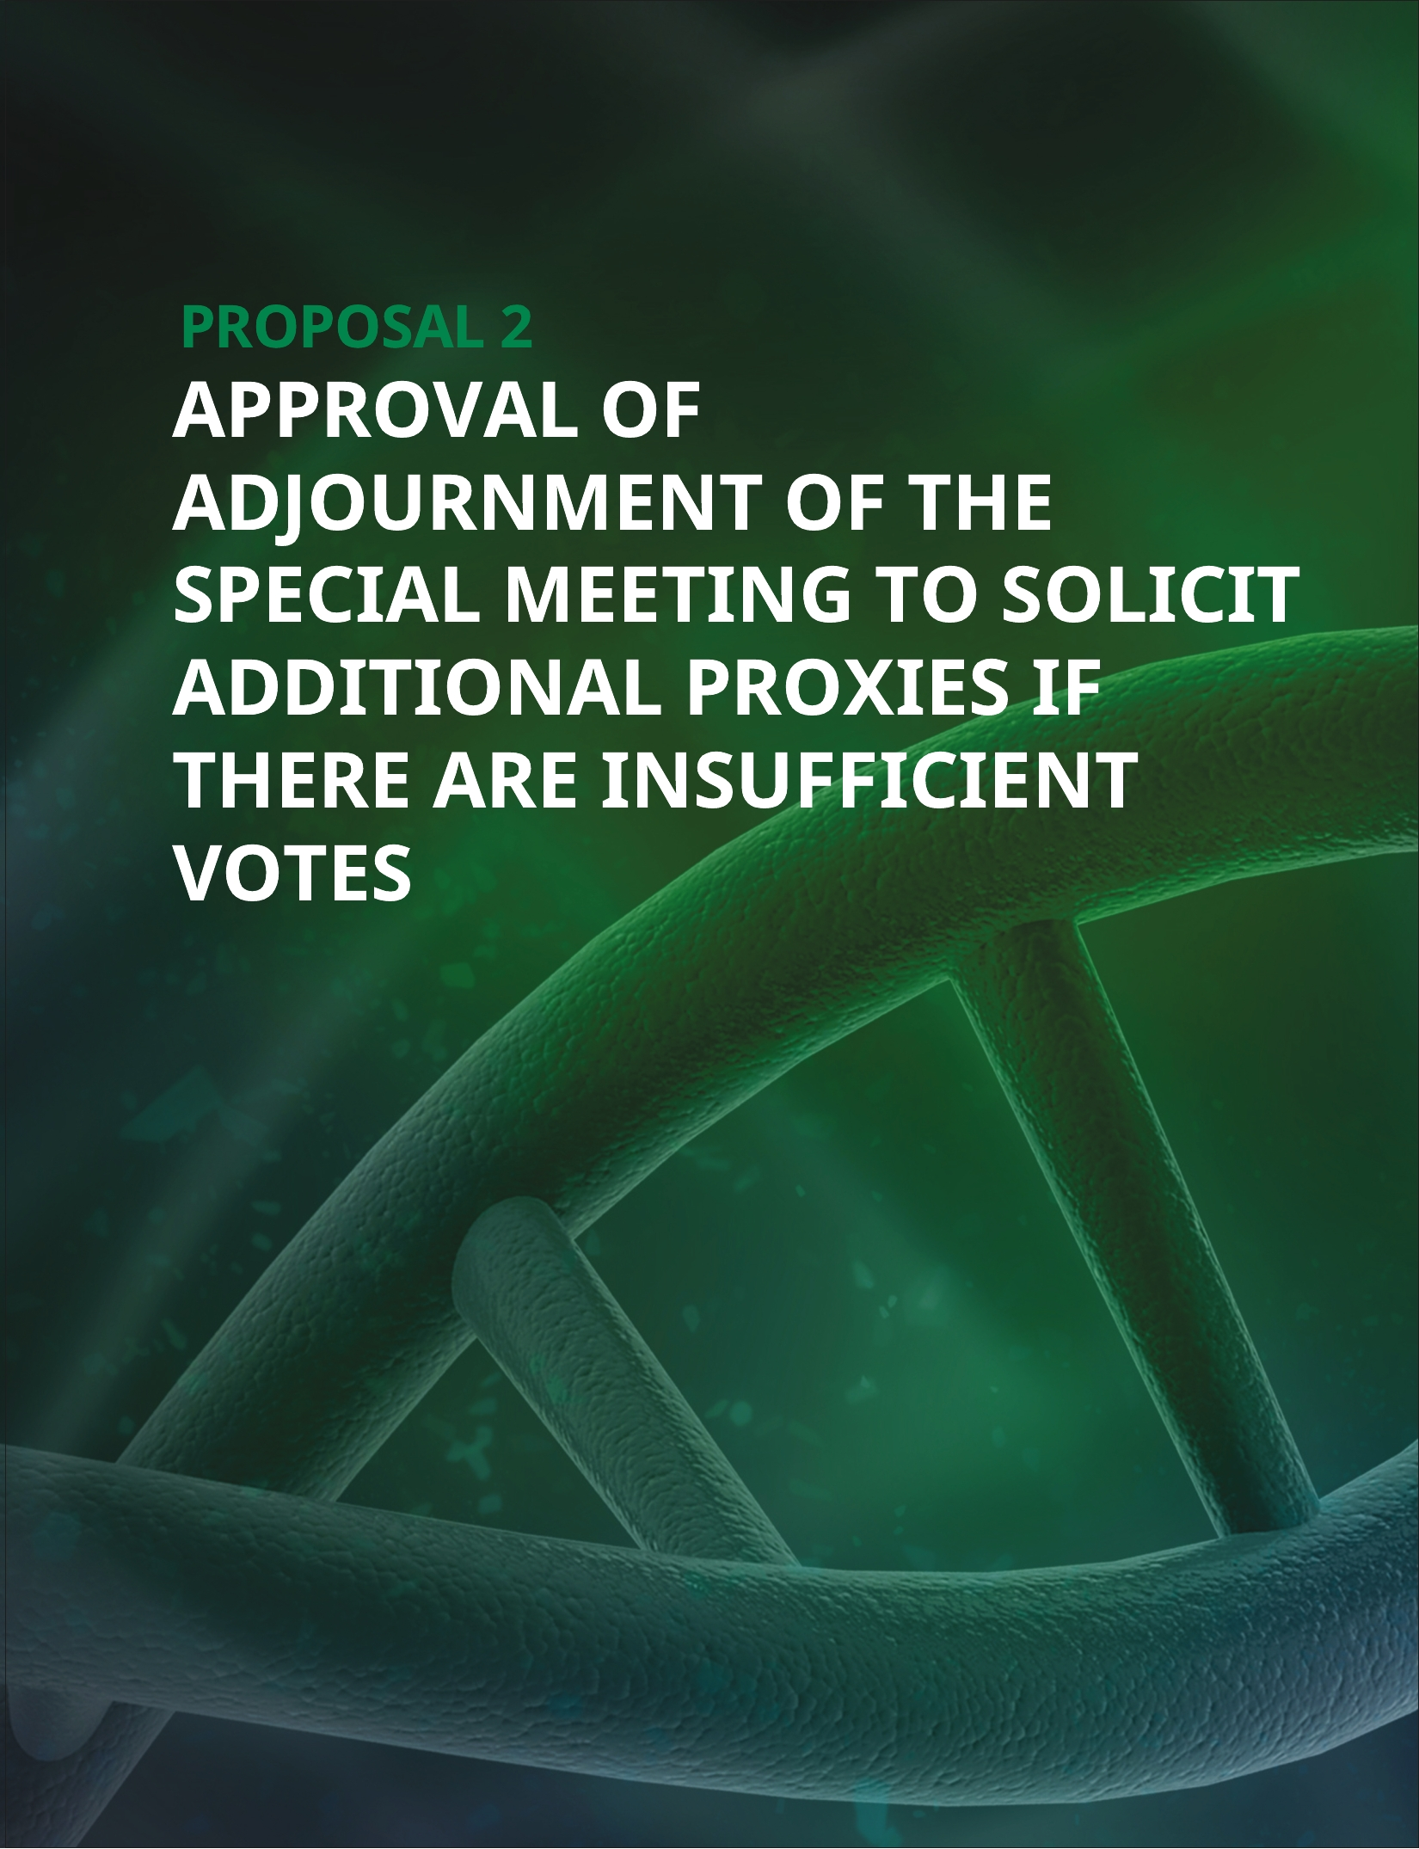

TABLE OF CONTENTS
APPROVAL OF ADJOURNMENT OF THE SPECIAL MEETING
This Adjournment Proposal, if adopted, will allow the Board to adjourn the Special Meeting to a later date or dates, if necessary or appropriate, to permit further solicitation and vote of proxies if, based upon the tabulated vote at the time of the Special Meeting, there are insufficient votes to approve Proposal 1. The Board believes that, if the number of shares of our common stock voting in favor of Proposal 1 is insufficient to approve such proposal, it is in the best interests of the stockholders to enable us, for a limited period of time, to seek to obtain a sufficient number of additional votes in favor of Proposal 1.
In the Adjournment Proposal, we are asking our stockholders to vote in favor of granting discretionary authority to the holders of any proxy solicited by the Board, and each of them individually, to approve a motion to adjourn the Special Meeting to another time and place for the purpose of soliciting additional proxies. For the avoidance of doubt, any proxy authorizing the adjournment of the Special Meeting will also authorize successive adjournments thereof, at any meeting so adjourned, to the extent necessary or appropriate for us to solicit additional proxies in favor of the approval of Proposal 1.
If stockholders approve the Adjournment Proposal, we could adjourn the Special Meeting and any adjourned session of the Special Meeting and use the additional time to solicit additional proxies in favor of Proposal 1.
THE BOARD UNANIMOUSLY RECOMMENDS A VOTE FOR THE APPROVAL OF THE ADJOURNMENT PROPOSAL.
6 | Notice of Special Meeting of Stockholders and Proxy Statement

TABLE OF CONTENTS
SECURITY OWNERSHIP OF CERTAIN BENEFICIAL OWNERS & MANAGEMENT
The following table sets forth certain information regarding the beneficial ownership of common stock as of the Record Date, by (a) each person known by us to be the beneficial owner of more than 5% of the outstanding shares of our common stock, (b) each named executive officer identified in the Summary Compensation Table in our definitive proxy statement for the 2026 Annual Meeting of Stockholders filed with the SEC on April 28, 2026 (the “Annual Meeting Proxy Statement”), (c) each director, and (d) all of our current executive officers and directors as a group.
The percentage of common stock outstanding is based on 339,110,401 shares of common stock outstanding as of the Record Date. For purposes of the table below, and in accordance with the rules of the SEC, we deem shares of common stock issuable upon the exercise of stock options or warrants that are currently exercisable or exercisable within 60 days of the Record Date to be outstanding and to be beneficially owned by the person holding the stock options or warrants for the purpose of computing the percentage ownership of that person, but we do not treat them as outstanding for the purpose of computing the percentage ownership of any other person. Except as otherwise noted, each of the persons or entities in this table has sole voting and investment power with respect to all of the shares of common stock beneficially owned by such person, subject to community property laws, where applicable. Except as otherwise noted below, the street address of each beneficial owner is c/o Ocugen, Inc., 11 Great Valley Parkway, Malvern, PA 19355.
 |  |  |  | Shares Beneficially Owned
 | Name of Beneficial Owner |  |  | Number of  Shares of  Common  Stock |  |  | Percentage  of  Common  Stock
 | Greater than 5% Stockholders
 | BlackRock, Inc. (1) |  |  | 26,952,492 |  |  | 7.95%
 | Janus Henderson Investors (2) |  |  | 20,000,000 |  |  | 5.90%
 | Millennium Management LLC (3) |  |  | 17,074,584 |  |  | 5.04%
 | Named Executive Officers, Directors and Director Nominees
 | Shankar Musunuri, Ph.D., MBA (4) |  |  | 9,815,476 |  |  | 2.84%
 | Ramesh Ramachandran (5) |  |  | 97,451 |  |  | *
 | Arun Upadhyay, Ph.D. (6) |  |  | 1,515,524 |  |  | *
 | Huma Qamar, M.D., MPH, CMI (7) |  |  | 210,080 |  |  | *
 | Junge Zhang, Ph.D. (8) |  |  | ​1,744,058 |  |  | *
 | Uday B. Kompella, Ph.D. (9) |  |  | 1,332,320 |  |  | *
 | Kirsten Castillo, MBA (10) |  |  | 699,876 |  |  | *
 | Blaise Coleman, MBA (11) |  |  | 50,439 |  |  | *
 | Satish Chandran, Ph.D. (12) |  |  | 85,439 |  |  | *
 | All executive officers and directors as a group (7 persons) (13) |  |  | ​13,748,958 |  |  | ​3.95%
* Represents beneficial ownership of less than one percent (1%) of the outstanding common stock.
(1) Based on a Schedule 13G filed with the SEC on July 29, 2026, BlackRock, Inc. has sole voting power over 26,625,805shares of our common stock and sole dispositive power over 26,952,492 shares of our common stock. The principalbusiness office of BlackRock, Inc. is 50 Hudson Yards, New York, New York 10001.
Notice of Special Meeting of Stockholders and Proxy Statement | 7

TABLE OF CONTENTS
(2) Based on a Schedule 13G filed with the SEC on December 8, 2025, Janus Henderson Group PLC. has sole votingpower over 20,000,000 shares of our common stock. The principal business office of Janus Henderson Group PLC is 201,Bishopsgate, EC2M 3AE, United Kingdom.
(3) Based on a Schedule 13G filed with the SEC on April 14, 2026, Millennium Group Management LLC has shared votingpower over 17,074,584 shares of our common stock. The principal business office of Millennium Group Management LLC is399 Park Avenue, New York, New York 10022.
(4) Consists of (i) 1,693,075 shares of common stock, 7,191 shares of common stock issuable pursuant to warrants exercisable within 60 days of the Record Date and 6,969,506 shares of common stock issuable pursuant to stock options exercisable within 60 days of the Record Date held by Dr. Musunuri; and (ii) 1,145,299 shares of common stock and 405 shares of common stock issuable pursuant to warrants exercisable within 60 days of the Record Date, in each case held by KVM Holdings, LLC. Dr. Musunuri is a member and officer of KVM Holdings, LLC and has voting and investment power over the shares held by KVM Holding, LLC.
(5) Consists of 1,800 shares of common stock and 95,651 shares of common stock issuable pursuant to stock options exercisable within 60 days of the Record Date, held by Mr. Ramachandran. Mr. Ramachandran resigned as our Chief Accounting Officer effective May 29, 2026. The number of shares of common stock reported as being beneficially owned by Mr. Ramachandran are based on the records available to the Company as of immediately after his resignation.
(6) Consists of 214,495 shares of common stock and 1,301,029 shares of common stock issuable pursuant to stock options exercisable within 60 days of the Record Date, held by Dr. Upadhyay.
(7) Consists of 4,436 shares of common stock and 205,644 shares of common stock issuable pursuant to stock options exercisable within 60 days of the Record Date, held by Dr. Qamar. Dr. Qamar separated as the Company’s Chief Medical Officer effective May 8, 2026. The number of shares of common stock reported as being beneficially owned by Dr. Qamar are based on the records available to the Company as of immediately after her separation.
(8) Consists of (i) 384,742 shares of common stock issuable pursuant to stock options exercisable within 60 days of the Record Date, held by Dr. Zhang and (ii) 1,359,316 shares of common stock held by Dr. Zhang.
(9) Consists of (i) 550,674 shares of common stock, 354 shares of common stock issuable pursuant to warrants exercisable within 60 days of the Record Date, and 626,876 shares of common stock issuable pursuant to stock options exercisable within 60 days of the Record Date, held by Dr. Kompella; and (ii) 154,416 shares of common stock held by Kompella LLC. Dr. Kompella has voting and investment power over the shares of common stock held by Kompella LLC.
(10) Consists of 75,000 shares of common stock and 624,876 shares of common stock issuable pursuant to stock options exercisable within 60 days of the Record Date, held by Ms. Castillo.
(11) Consists of 50,439 shares of common stock issuable pursuant to stock options exercisable within 60 days of the Record Date, held by Mr. Coleman.
(12) Consists of 85,439 shares of common stock issuable pursuant to stock options exercisable within 60 days of the Record Date, held by Dr. Chandran.
(13) Consists of 4,999,130 shares of common stock, 7,950 shares of common stock issuable pursuant to warrants exercisable within 60 days of the Record Date, and 8,741,878 shares of common stock issuable pursuant to stock options exercisable within 60 days of the Record Date.
8 | Notice of Special Meeting of Stockholders and Proxy Statement

TABLE OF CONTENTS
GENERAL INFORMATION
The Notice of Availability or the Notice of the Special Meeting (the “Notice”), this Proxy Statement, and a form of the proxy card, as applicable, are first being mailed to our stockholders on or about July 30, 2026. In accordance with the rules of the SEC, we are advising our stockholders of the availability on the Internet of our proxy materials related to our Special Meeting. The Notice, this Proxy Statement, and your proxy card are available to holders of our common stock at www.proxyvote.com.
STOCKHOLDERS ENTITLED TO VOTE
All holders of our common stock at the close of business on the Record Date are entitled to receive the Notice and to vote their shares at the Special Meeting. As of the Record Date, there were outstanding 339,110,401 shares of our common stock. Each share of common stock is entitled to one vote on each matter properly brought to the Special Meeting. Stockholders have no dissenters’ or appraisal rights in connection with any of the proposals described herein.
ATTENDING THE SPECIAL MEETING
We will be hosting the Special Meeting live via audio webcast. Any stockholders can attend the Special Meeting online at www.virtualshareholdermeeting.com/OCGN2026SM. If you are a stockholder as of the Record Date or you hold a valid proxy for the Special Meeting, you can vote at the Special Meeting. A summary of the information you need to attend the Special Meeting online is provided below:
• | Instructions on how to attend and participate via the Internet, including how to demonstrate proof of stock ownership, are posted at www.virtualshareholdermeeting.com/OCGN2026SM and included in the Notice of Availability.
• | Assistance with questions regarding how to attend and participate via the Internet will be provided at www.virtualshareholdermeeting.com/OCGN2026SM on the day of the Special Meeting.
• | The webcast will start on September 21, 2026 at 8 a.m., Eastern Time.
• | You will need your 16-digit control number to enter the Special Meeting.
• | Stockholders may submit questions while attending the Special Meeting via the Internet.
• | Webcast replay of the Special Meeting will be available until September 21, 2027.
To attend and participate in the Special Meeting, you will need the 16-digit control number included in the Notice of Availability, on your proxy card, or on the instructions that accompanied your proxy materials. If your shares are held in “street name,” you should contact your bank or broker to obtain your 16-digit control number or otherwise vote through the bank or broker. If you lose your 16-digit control number, you may join the Special Meeting as a “Guest,” but you will not be able to vote, ask questions, or access the list of stockholders as of the Record Date.
During the virtual Special Meeting, you may only submit questions in the question box provided at www.virtualshareholdermeeting.com/OCGN2026SM. We will respond to as many inquiries at the Special Meeting as time allows.
We will have technicians ready to assist you with any technical difficulties you may have while accessing the Special Meeting website. If you encounter any difficulties accessing the virtual Special Meeting during the check-in or meeting time, please call the technical support number that will be posted on the Special Meeting website’s log-in page.
Notice of Special Meeting of Stockholders and Proxy Statement | 9

TABLE OF CONTENTS
OTHER MATTERS
The Special Meeting is called for the purposes set forth in the Notice. Our Board is not aware of any other matters to be considered by the stockholders at the Special Meeting other than the matters described in the Notice. Accordingly, other than procedural matters relating to the proposals, no other business may properly come before the Special Meeting. Should any procedural matter requiring a vote of stockholders arise, it is the intention of the persons named in the proxy card to vote in accordance with their best judgment on any such matter.
REQUIREMENTS FOR SUBMISSION OF DIRECTOR NOMINATIONS AND STOCKHOLDER PROPOSALS FOR NEXT YEAR’S ANNUAL MEETING
In order to be considered for inclusion in the proxy statement for our 2027 Annual Meeting of Stockholders, stockholders interested in submitting a proposal or nominating a director for election at our 2027 Annual Meeting of Stockholders may do so by following the procedures prescribed in Rule 14a-8 promulgated under the Exchange Act. To be eligible for inclusion in our proxy materials, stockholder director nominations or proposals must be received at our principal executive offices no later than the close of business on December 29, 2026, which is the 120th day prior to the first anniversary we released the Annual Meeting Proxy Statement to our stockholders for this year’s Annual Meeting. To be included in our proxy materials, your director nomination or proposal must also comply with our Bylaws and Rule 14a-8 promulgated under the Exchange Act. If we change the date of the 2027 Annual Meeting of Stockholders by more than 30 days from the anniversary of this year’s Annual Meeting, stockholders nominations or proposals must be received at a reasonable time before we begin to make available the proxy materials for the 2027 Annual Meeting of Stockholders in order to be considered for inclusion in our Proxy Statement. Such proposals should be sent to Ocugen, Inc., 11 Great Valley Parkway, Malvern, PA 19355 Attention: Corporate Secretary.
Alternatively, stockholders intending to present a proposal or nominate a director for election at the 2027 Annual Meeting of Stockholders without having the proposal or nomination included in our proxy statement must deliver written notice of the nomination or proposal to our Corporate Secretary at our principal executive offices no earlier than February 12, 2027, which is the 75th day prior to the first anniversary of the date we released the Annual Meeting Proxy Statement for this year’s Annual Meeting to our stockholders, and no later than March 14, 2027, which is the 45th day prior to the first anniversary of the date we released the Annual Meeting Proxy Statement for this year’s Annual Meeting to our stockholders. However, if we change the date of our 2027 Annual Meeting of Stockholders by more than 30 days from the anniversary of this year’s Annual Meeting, such nominations and proposals must be received no later than the close of business on the later of (a) the 90th day prior to our 2027 Annual Meeting of Stockholders and (b) the 10th day following the day we first publicly announce the date of our 2027 Annual Meeting of Stockholders. The stockholder’s written notice must include certain information concerning the stockholders and each nominee and proposal, as specified in our Bylaws. If the stockholder does not also satisfy the requirements of Rule 14a-4 promulgated under the Exchange Act, the persons named as proxies will be allowed to use their discretionary voting authority when and if the matter is raised at the 2027 Annual Meeting of Stockholders. Such nominations or proposals should be sent to Ocugen, Inc., 11 Great Valley Parkway, Malvern, PA 19355 Attention: Corporate Secretary.
In addition, to comply with the universal proxy rules, stockholders intending to solicit proxies in support of director nominees other than our nominee must provide notice that sets forth the information required by Rule 14a-19 under the Exchange Act no later than April 12, 2027.
10 | Notice of Special Meeting of Stockholders and Proxy Statement

TABLE OF CONTENTS
STOCKHOLDER COMMUNICATIONS TO THE BOARD
Stockholders and other interested parties may communicate with the Board by writing to the Corporate Secretary, Ocugen, Inc., 11 Great Valley Parkway, Malvern, PA 19355. Communications intended for a specific director or directors should be addressed to their attention to the Corporate Secretary at the address provided above. Communications received from stockholders are forwarded directly to Board members as part of the materials provided in advance of the next scheduled Board meeting following receipt of the communications. The Board has authorized the Corporate Secretary, at his discretion, to forward communications on a more expedited basis if circumstances warrant, or to exclude a communication if it is illegal, unduly hostile or threatening, or similarly inappropriate. Advertisements, solicitations for periodical or other subscriptions, and other similar communications generally will not be forwarded to the directors. You may submit your concern anonymously or confidentially by postal mail. You may also indicate whether you are a stockholder, customer, supplier or other interested party. The matter that you submitted may be discussed with our legal counsel, with independent advisors, with non-management directors, or with our management. The Board may take other action or no action as it determines in good faith, using reasonable judgment and applying the discretion.
AVAILABILITY OF MATERIALS
Our 2025 Annual Report, including the financial statements and financial statement schedules, has been filed with the SEC and provides additional information about us, which is incorporated herein by reference. We will mail the Notice of Availability or the Notice of the Special Meeting, this Proxy Statement, and a form of the proxy card, as applicable, on or about July 30, 2026. In accordance with the rules of the SEC, we are advising our stockholders of the availability on the Internet of our proxy materials related to our forthcoming Special Meeting. The Proxy Materials are available to holders of our common stock at www.proxyvote.com.
VOTING METHODS
You may vote at the Special Meeting by voting online during the live audio webcast or you may cast your vote in any of the following ways:
 |  |  |  |  |  | 
​Mailing your signed proxy card or  voter instruction card |  |  | Using the Internet at  www.proxyvote.com |  |  | Calling toll-free from the United  States, U.S. territories and  Canada to 1-800-690-6903
Notice of Special Meeting of Stockholders and Proxy Statement | 11

TABLE OF CONTENTS
If you have any questions or need assistance voting your shares, please reach out to our proxy solicitor:
Campaign Management: Strategic Stockholder Advisor and Proxy Solicitation Agent: 15 West 38th Street, Suite #747, New York, New York 10018.


North American Toll-Free Phone:1-844-399-2361
Email: info@campaign-mgmt.com
Call Collect Outside North America: +1 (212) 632-842
HOW YOUR SHARES WILL BE VOTED
In each case, your shares will be voted as you instruct. If you return a signed card, but do not provide voting instructions, your shares will be voted FOR each of Proposals 1 and 2. If you are the record holder of your shares, you may revoke or change your vote any time before the proxy is exercised. To do so, you must do one of the following:
• | Submit a proxy to vote over the Internet at www.proxyvote.com or by telephone as instructed above. Only your latest Internet or telephone proxy is counted. You may not revoke or change your vote over the Internet at www.proxyvote.com or by telephone after 11:59 p.m. Eastern Time on September 20, 2026.
• | Sign a new proxy card and submit it by mail, which must be received no later than September 20, 2026. Only your latest dated proxy card will be counted.
• | Attend the Special Meeting at www.virtualshareholdermeeting.com/OCGN2026SM and vote online during the live audio webcast. Attending the Special Meeting will not by itself revoke a previously granted proxy.
• | Give our Corporate Secretary written notice at IR@ocugen.com before or at the Special Meeting that you want to revoke your proxy.
If your shares are held by your broker, bank, or other holder of record as a nominee or agent (i.e., the shares are held in “street name”), you should follow the instructions provided by your broker, bank, or other holder of record.
Deadline for Voting. The deadline for submitting a proxy to vote by telephone or Internet at www.proxyvote.com is 11:59 p.m. Eastern Time on September 20, 2026. If you are a registered stockholder and attend the Special Meeting, you may also vote online during the Special Meeting at www.virtualshareholdermeeting.com/OCGN2026SM.
12 | Notice of Special Meeting of Stockholders and Proxy Statement

TABLE OF CONTENTS
BROKER VOTING AND VOTES REQUIRED FOR EACH PROPOSAL
If your shares are held in a stock brokerage account or by a bank or other holder of record, you are considered the “beneficial owner” of shares held in street name, and your broker, bank, or other holder of record is considered the stockholder of record of those shares. As the beneficial owner, you may direct your broker, bank, or other holder of record on how to vote your shares by following their instructions for voting.
A broker non-vote occurs when a broker or other nominee that holds shares for another does not vote on a particular item because the nominee does not have discretionary voting authority for that item and has not received instructions from the beneficial owner of the shares. The following table summarizes how broker non-votes and abstentions are treated with respect to our proposals:
 |  |  |  | Proposal |  |  | Votes Required |  |  | Treatment of  Abstentions and  Broker Non-Votes |  |  | Broker  Discretionary  Voting
 | Proposal 1: |  |  | Approval of the adoption of an amendment to our Charter to increase the number of authorized shares of common stock by 250,000,000 shares |  |  | Majority of the voting power of all of the then-outstanding shares of our capital stock entitled to vote generally in the election of directors, voting together as a single class |  |  | Abstentions will have the same effect of a vote “AGAINST” this proposal.  Brokers have discretion to vote on this proposal, and so we do not expect there to be broker non-votes with respect to this proposal |  |  | Yes
 | Proposal 2: |  |  | Approval of an adjournment of the Special Meeting, if necessary or appropriate, to solicit additional proxies if there are insufficient votes at the time of the Special Meeting to approve Proposal 1 |  |  | Majority of the voting power of the outstanding voting stock present in person or represented by proxy at the meeting, and entitled to vote on this matter |  |  | Abstentions will have the same effect of a vote “AGAINST” this proposal.  Brokers have discretion to vote on this proposal, and so we do not expect there to be broker non-votes with respect to this proposal |  |  | Yes
Notice of Special Meeting of Stockholders and Proxy Statement | 13

TABLE OF CONTENTS
QUORUM
We must have a quorum to conduct business at the Special Meeting. A quorum consists of the presence at the meeting, either online during the live audio webcast or represented by proxy, of the holders of one-third of the voting power of our outstanding shares entitled to vote generally in the election of directors. For the purpose of establishing a quorum, votes withheld, abstentions, including brokers holding customers’ shares of record who cause abstentions to be recorded at the meeting, and broker non-votes are considered stockholders who are present and count toward the quorum. If there is no quorum, the chairman of the meeting may adjourn the meeting to another date.
PROXY SOLICITATION COSTS
We pay the cost of soliciting proxies. Proxies will be solicited on behalf of the Board by mail, telephone and other electronic means, or in person. Directors and employees will not be paid any additional compensation for soliciting proxies. We have retained Campaign Management LLC to assist in the solicitation of proxies for the Special Meeting for a fee of approximately $13,000 plus additional fees for requested services and reimbursement of expenses. Campaign Management may be reached at (844) 399-2361 in North American and +1 (212) 632-842 outside of North America or via email at info@campaign-mgmt.com. We may also reimburse brokerage firms, banks, and other agents for the cost of forwarding proxy materials to beneficial owners. Our Board, officers and employees, as well as Campaign Management LLC, our proxy solicitation firm, may solicit proxies on behalf of the Board in person, by mail, telephone, fax and other electronic means.
HOUSEHOLDING
Some banks, brokers and other nominee record holders may be participating in the practice of “householding” proxy statements and annual reports. This means that only one copy of our documents, including the proxy statement, may have been sent to multiple stockholders in your household. We will promptly deliver a separate copy of the proxy statement to you upon written or oral request to Ocugen, Inc., 11 Great Valley Parkway, Malvern, PA 19355, Attention: Corporate Secretary, telephone: 484-328-4701. If you want to receive separate copies of proxy statements or annual reports to stockholders in the future, or if you are receiving multiple copies and would like to receive only one copy per household, you should contact your bank, broker or other nominee record holder, or you may contact us at the above address and phone number.
14 | Notice of Special Meeting of Stockholders and Proxy Statement

TABLE OF CONTENTS
Appendix A
CERTIFICATE OF AMENDMENT
TO
SIXTH AMENDED AND RESTATED CERTIFICATE OF
INCORPORATION
OF
OCUGEN, INC.
(Pursuant to Section 242 of the
General Corporation Law of the State of Delaware)
Ocugen, Inc., a corporation organized and existing under and by virtue of the General Corporation Law of the State of Delaware (the “Corporation”), does hereby certify as follows:
1. | The name of the Corporation is Ocugen, Inc.
2. | That a resolution was duly adopted by the Board of Directors of the Corporation pursuant to Section 242 of the General Corporation Law of the State of Delaware (the “DGCL”) setting forth an amendment to the Sixth Amended and Restated Certificate of Incorporation, as amended (the “Sixth Amended and Restated Certificate of Incorporation”), and declaring said amendment to be advisable. The requisite stockholders of the Corporation have duly approved the proposed amendment in accordance with Section 242 of the DGCL. The amendment amends the Sixth Amended and Restated Certificate of Incorporation as follows:
3. | Paragraph A of Article IV of the Sixth Amended and Restated Certificate of Incorporation of the Corporation is hereby amended and restated in its entirety as follows:
“A. The total number of shares of all classes of stock which the Corporation shall have authority to issue is six hundred fifty million (650,000,000), consisting of six hundred forty million (640,000,000) shares of Common Stock, par value $0.01 per share (the “Common Stock”), and ten million (10,000,000) shares of Preferred Stock, par value $0.01 per share (the “Preferred Stock”).”
4. | This Certificate of Amendment shall become effective on , 2026 at 12:01 a.m. Eastern Time.
5. | Except as set forth in this Certificate of Amendment, the Sixth Amended and Restated Certificate of Incorporation, as amended, remains in full force and effect.
IN WITNESS WHEREOF, Ocugen, Inc. has caused this Certificate to be executed by its duly authorized officer on this day of , 2026.
OCUGEN, INC.
By:
Name:
Title:
Notice of Special Meeting of Stockholders and Proxy Statement | A-1

TABLE OF CONTENTS
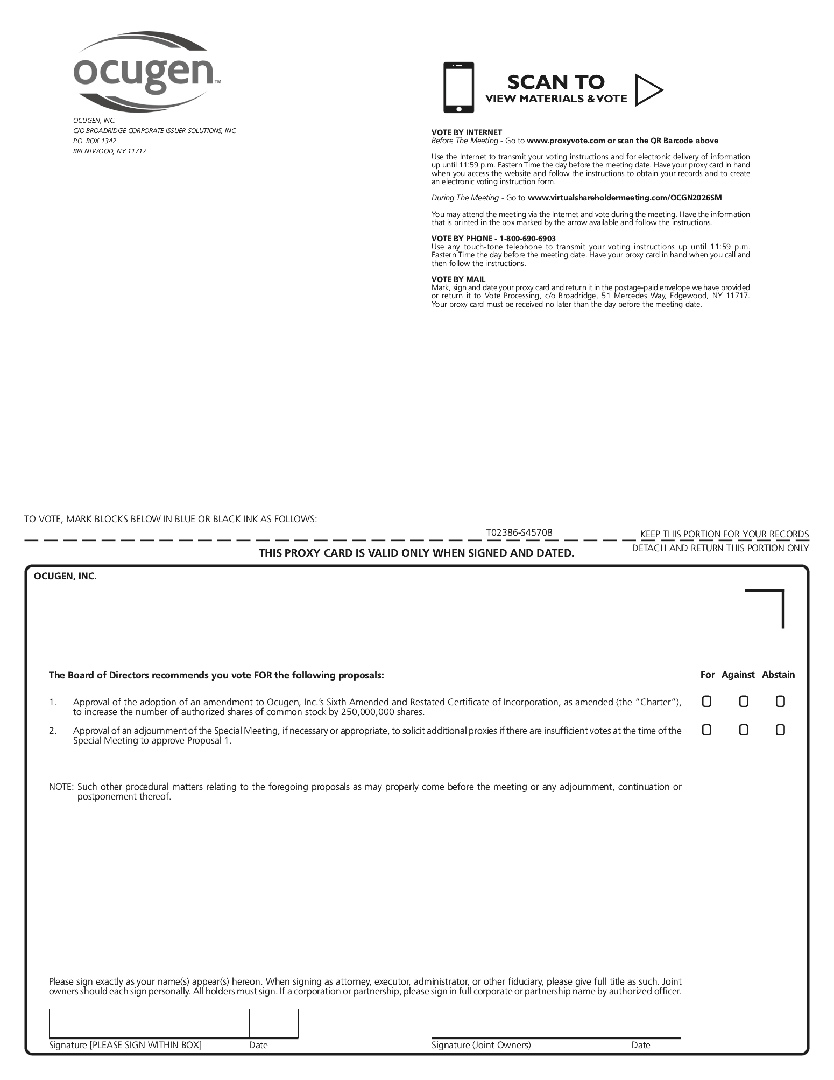

TABLE OF CONTENTS


